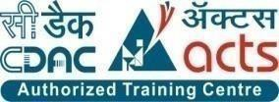

INSTITUTE FOR ADVANCED COMPUTING AND SOFTWARE DEVELOPMENT AKURDI, PUNE

Documentation On:

“DairyExpress”- Online Dairy Products Store

PG-DAC SEPT 2022

## Submitted By:

**Group No: 27**

**Roll No. Name:**

**229042 Mahendra R. Kolhe**

**229099 Sujay S. Mathane**

## Mr. Rohit Puranik Mrs.Megha Mane

**Centre Coordinator Project Guide**

**ABSTRACT**

This Dairy Express App project will basically be an easy-to-use web application that will allow customers to easily purchase and order products for delivery. It is basically for providing a platform for registering users, categories, products, managing stocks and orders and an end-to-end system from order-to –delivery-to –payment services.

This project presents a theoretical framework for Dairy Products Store, it discussed about ordering dairy products items from our need .After Ordering, the details are processed and a delivery person is assigned for carrying out the delivery available in that region. The Order goes through various stages like “PLACED, PACKING, READY, OUT_FOR_DELIVERY, DELIVERED & CANCELED”.

This project discussed the tool and technology used in developing the proposed system (the system has a front end by REACT to display the content structure and a back end of database using MySQL and Spring Boot i.e. J2EE). A number of development methodologies were discussed and why one of the methodologies was chosen for this project. Methods used to gather the requirement specification was also discussed and how the researcher will use this as a guideline in developing the proposed system.

**AKNOWLEDGEMENT**

I take this occasion to thank God, almighty for blessing us with his grace and taking our endeavor to a successful culmination. I extend my sincere and heartfelt thanks to our esteemed guide, **Mrs.Megha Mane** for providing me with the right guidance and advice at the crucial juncture sand for showing me the right way. I extend my sincere thanks to our respected **Centre Co-Ordinator Mr. Rohit Puranik**, for allowing us to use the facilities available. I would like to thank the other faculty members also, at this occasion. Last but not the least, I would like to thank my friends and family for the support and encouragement they have given me during the course of our work.

**Mahendra Kolhe (229042)**

**Sujay Mathane (229099)**

**Table of Contents**

|  |  |  |
| --- | --- | --- |
| **1** | **INTRODUCTION** | **9** |
|  | 1.1 Project Objective | **9** |
|  | 1.2 Project Scope | **10** |
|  | 1.3 Study of System | **10** |
|  | 1.3.1 User Classes and Functionality | **10** |
|  | 1.3.2 Technology Used | **11** |
|  | 1.3.3 Functional Requirement | **11** |
|  | Functional Diagrams | **12** |
|  | Activity Diagrams | **15** |
| **2** | **SYSTEM ANALYSIS** | **15** |
|  | 2.1 System Requirement Specification | **7** |
| **3** | **DATABASE DESIGN** |  |
|  | 3.1 Database | **18** |
|  | 3.2 System Tools | **18** |
|  | 3.2.1 Front End  . | **18** |
|  | 3.2.1 Back End  . | **18** |
|  | DFD Diagram | **19** |
|  | ER Diagrams | **20** |
|  | Class Diagram | **22** |
|  | Table Structure | **23** |
| **4** | **PROJECT SCREENSHOT** | **28** |
| **5** | **CONCLUSION** | **36** |
| **6** | **REFERENCES** | **37** |

**LIST OF TABLES**

|  |  |  |
| --- | --- | --- |
| **SECTION** | **TABLE LIST** | **PAGE** |
| 1 | **USERS** | **24** |
| 2 | **STOCK** | **25** |
| 3 | **PRODUCTS** | **25** |
| 4 | **PAYMENTS** | **25** |
| 5 | **ORDER_DETAILS** | **26** |
| 6 | **ORDERS** | **26** |
| 7 | **CART** | **26** |
| 8 | **CATEGORIES** | **27** |
| 9 | **ADDRESS** | **27** |

**LIST OF FIGURES**

|  |  |  |
| --- | --- | --- |
| SECTION | DIAGRAM TITLE | PAGE |
| 1 | Admin Functionality | 11 |
| 2 | Employee Functionality | 12 |
| 3 | Customer Functionality | 13 |
| 4 | Delivery Executive Functionality | 13 |
| 5 | Activity Diagram | 14 |
| 6 | DFD for Customer | 19 |
| 7 | DFD for Admin | 19 |
| 8 | ER Diagram software generated | 20 |
| 9 | ER Diagram Manually Drawn | 21 |
| 10 | Class Diagram | 22 |

**1.INTRODUCTION**

The web based “Dairy Express” project is an attempt to stimulate the basic concepts of Online dairy products store. The system enables the customer to do the things such as search for Products category wise, choose products based on description and add that product into cart.

The system provides you details about product. If user want to buy product, he must have registered account.

The system shows the product that are available or that are in stock, the system displays price, quantity, availability of product to user as well as employees of store

Here we provided products by Company wise that allows customer to choose a particular product easily. The product which are not in stock, user cannot add those products into cart. If the products are available then the system allows the user to add product into cart.

To place order system, ask user to select the address and payment mode. If address is not provided the user can’t place order, User have to specify the address before placing order. After selecting address and payment mode user can place order and the same updates will be done in database.

The system has admin who can add new employees or can remove employees, also admin can add or can remove products. Also, he can see the availability of products. Admin can change other employees Role “Admin”.

The System have employee also who can perform tasks like add or remove products. Also, employee can add delivery person. Employee can edit product details.

* 1. **PROJECT OBJECTIVE**

The objective of this project is based on the delivery of dairy products at your doorstep. This application will provide you a convenient and hassle-free service which is taken care by us. The Dairy Express project will basically be an easy-to-use web application that will allow customers to easily purchase and order products for delivery. It is basically for providing a platform for registering users, categories, products, managing stocks and orders.

* 1. **PROJECT SCOPE**
  + Small and medium scale store, have to manage data about customers, services offered to them.
  + It is difficult for small scale businesses to maintain data for longer time as they are using paper-based system.
  + Customers also need to find nearest store which provide authentic service.
  + Using this system, they will be able to maintain customer and services data.
  + Also, multiple services centers which are using the same system will be able to synchronize their work.
  + We are also solving the problem from customer's end by making ease of choice. They can choose the products from different category and from different brands.
  1. **STUDY OF THE SYSTEM**
     1. **USER CLASSES AND CHARACTERISTICS**

In this software, there is an Admin. Admin can add new Employees which is also another part of system. Admin can see stock and sales. The admin user can edit Employee details. Employees can add Delivery person for delivery of orders. Employees can see order list and order status. Employee can add new category of products. Customer can use the software for registering to the system. Customer can purchase different products and can place order.

* + 1. **TECHNOLOGIES USED**
* MySQL
* Spring Boot
* React-JS
  + 1. **FUNCTIONAL REQUIREMENTS**

The major functionality of this product is divided into three categories.

* Administrative Functions.
* Employee Functions.
* Customer Functions.

In this application each and every user must have their own Email ID and Password, using these Email ID and Password only they can directly enter into their corresponding Login forms.

System analysis will be performed to determine if it is feasible to design information based on policies and plans of the organization and on user requirements and to eliminate the weaknesses of the present system.

Administrative Functions:

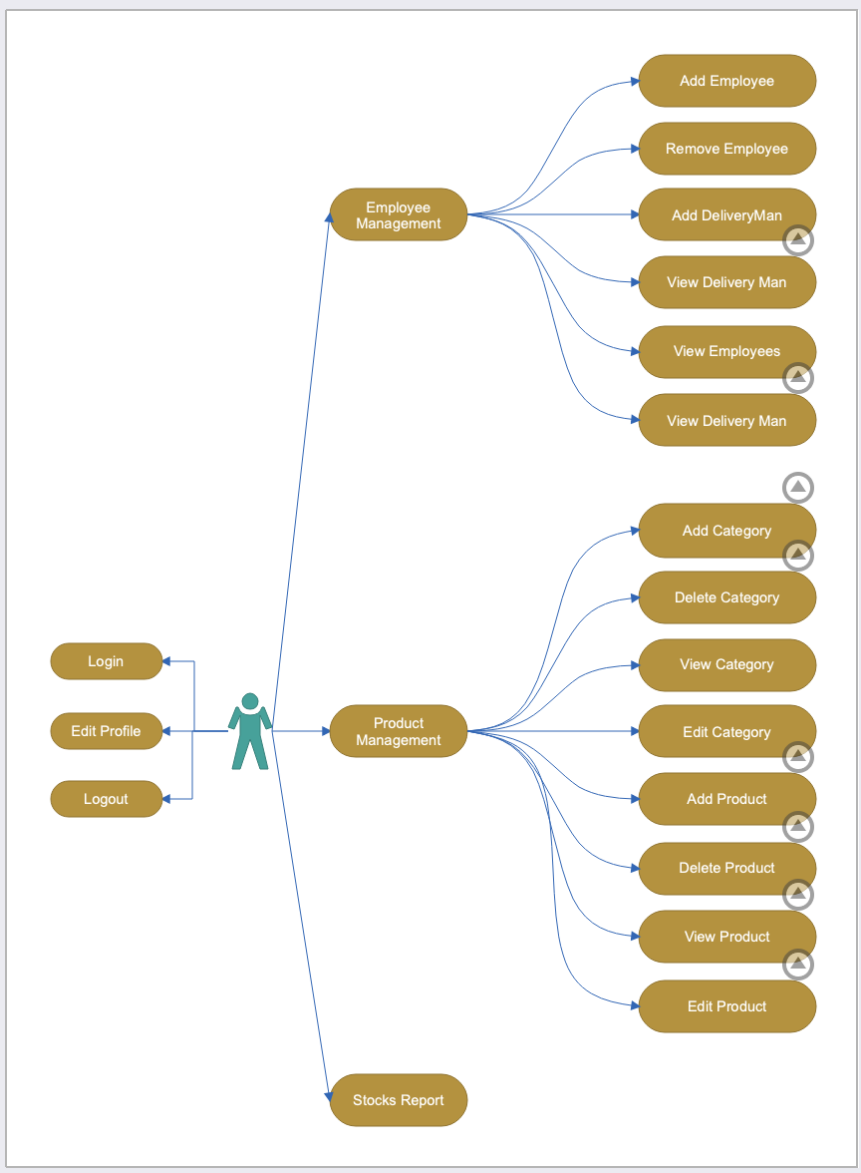

Employee Function:

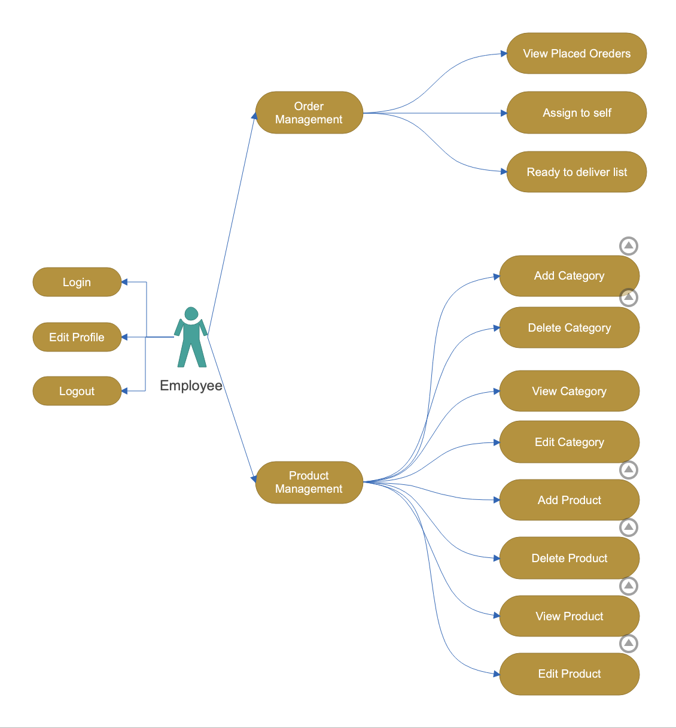

Customer Function:

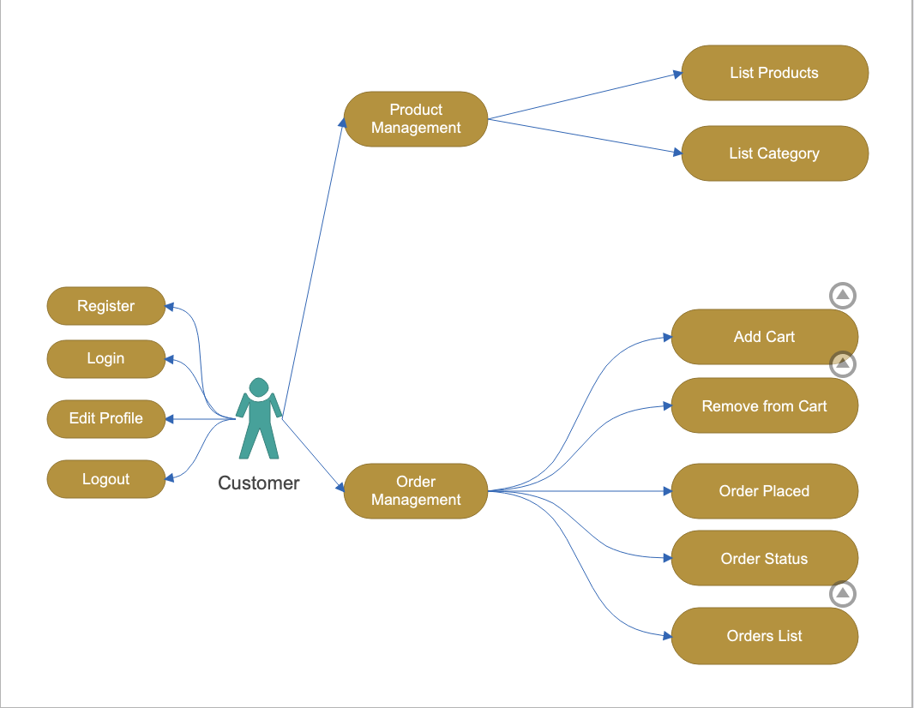

Delivery Function:

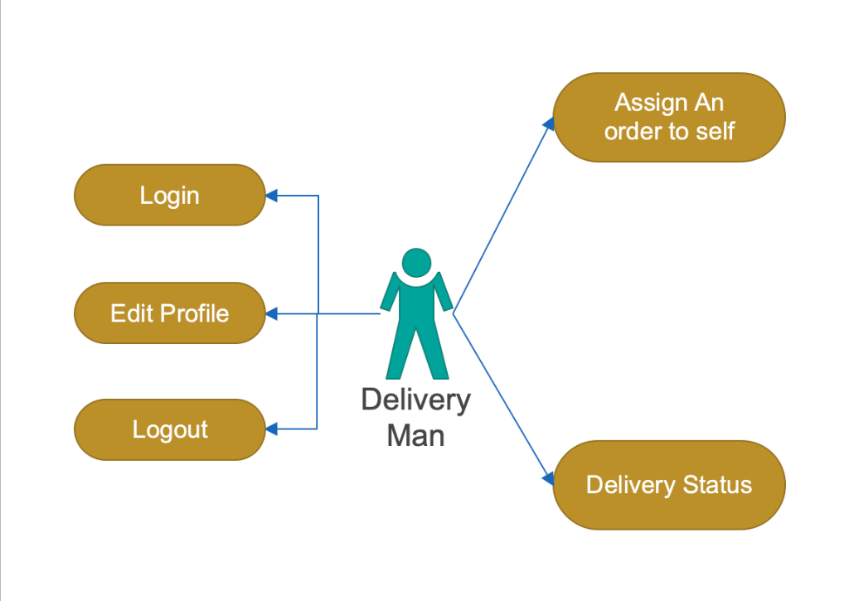

Activity Diagram:

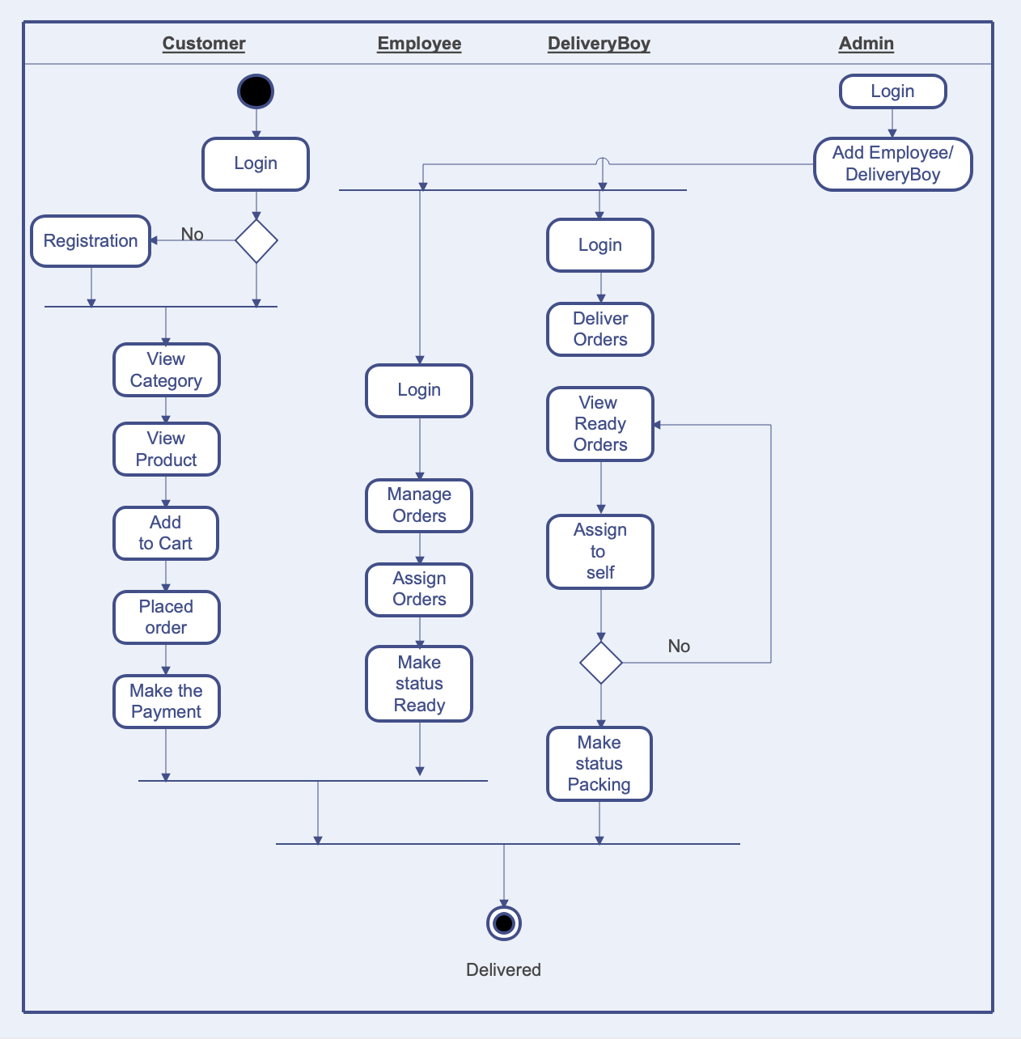

**2.SYSTEM ANALYSIS**

System analysis is the process of gathering and interpreting facts, diagnosing problems, and using the information to recommend improvements on the system. System analysis is a problem-solving activity that requires intensive communication between the system users and system developers.

System analysis or study is an important phase of any system development process. The system is viewed as a whole, the inputs are identified, and the system is subjected to close study to identify the problem areas. The solutions are given as a proposal. The proposal is reviewed on user request and suitable changes are made. This loop ends as soon as the user is satisfied with the proposal.

**2.1 SYSTEM REQUIREMENT SPECIFICATION**

**Tittle**: System Requirement for Online Dairy Products delivery portal.

**Product Description:** DairyExpress Platform can be the greatest blessing for the customer’s everyday morning needs of dairy products. With this platform customer can register and order their daily requirements of dairy products and receives assured delivery at the desire time every day at their doorstep.

**Problem Statement:** Daily needs like milk and other dairy products are critical every morning for a household and it is extremely important to have timely delivery as one’s schedules depend on these items.

**System Objectives:** To provide a Web platform for online shopping of dairy products.

**Functional Requirements :** Any anonymous User will be able to view different products available for sale. Any User will be able select product to view from categories available. Employee will be to track and maintain stock of products available for sale. Employee will be able to raise requests for product updatation to Admin.

**For Consumer Panel:**

* Register and manage profile
* Add address
* Browse and sort through milk products Place an order
* Ratings and reviews
* Get order invoice via mail
* Refer a friend
* View discounts and offer
* View order history
* Select preferred delivery time
* Set vacation days for no deliver

**For Admin Panel:**

* Add product inventory
* Manage to the price of milk products Manage order and deliveries Manage payments
* Secure login to the admin dashboard Manage delivery executives
* Manage offers and discounts Manage orders
* Manage CMS
* Manage Employees
* Track order deliveries
* View ratings and reviews
* Generate reports

**For Delivery Executive Panel:**

* Create and manage profile
* View orders assigned
* View order details
* View customer location for delivery
* In-app call and chat with customer
* View order history

**Non-Functional Requirements :**

**Security:** Registered Customer will allowed to place an order. Each stakeholder will be to access system through authentication process. Who are you ? System will provide access to the content , operations using Role based security (Authorization) (Permissions based on Role) Using SSL in all transactions which will be performed stakeholder. It would protect confidential information shared by system to stake holder of Shared by stakeholder to system. System will automatically log of all stakeholder after some time due to inactiveness. System will block operations for inactive stakeholder and would redirect for authentication. System will internally maintain secure communication channel between Servers ( Web Servers, App Servers, database Server) Sensitive data will be always encrypted across communication. User proper firewall to protect servers from outside fishing, vulnerable attacks.

**Reliability :** The system will backup business data on regular basis and recover in short time duration to keep system operational Continuous updates are maintained , continuous Administration is done to keep system operational. During peak hours system will maintain same user experience by managing load balancing.

**Availability :** uptime: 24* 7 available 99.999%.

**Maintainability:** A Commercial database software will be used to maintain System data Persistence. A readymade Web Server will be installed to host online DairyExpress portal (Web Site) to management server capabilities. IT operations team will easily monitor and configure System using Administrative tools provided by Servers. Separate environment will be maintained for system for isolation in production, testing, and development.

**Portability:**  PDA: Portable Device Application System will provide portable User Interface ( HTML, CSS, JS) through users will be able to access online DairyExpress portal. System can be deployed to single server, multi-server, to any OS, Cloud (Azure or AWS or GCP)

**Accessibility:** only registered customer will be able to place an order after authentication. BOD team will be able to view daily, weekly, monthly, annual business Growth through customized dashboard.

**Durability:**  System will retain customer shopping cart for 15 minutes even though customer loose internet connection and join again. System will maintain Wishlist for customer . customer will be able to add products from wish list and add to shopping cart whenever needed. System will implement backup and recovery for retaining stake holders data, business operation data and business data over time.

**Efficiency:** System will designed and developed using reusable, independent or dependent business scenarios in the form of modules. These modules will be loosely coupled and highly cohesive. System will contain CRM , Inventory , shopping cart, order processing, payment processing, Delivery module, membership and Roles management modules.

**Scalability:** System will be able to provide consistent user experience to stake holder as well as visitors irrespective of load.

**Safety:** online DairyExpress portal will be secure from malicious attack, fishing. online DairyExpress portal functionalities are protected from outside with proper firewall configuration. online DairyExpress portal will be always kept updated with latest anti-virus software. Business data will be backed up periodically to ensure safety of data using incremental back up strategy. Role based security will be applied for Application data and operations accessibility.

**3.DATABASE DESIGN**

* 1. **DATABASE**

Databases are the storehouses of data used in the software systems. The data is stored in tables inside the database. Several tables are created for the manipulation of the data for the system. Two essential settings for a database are

* Primary key - the field that is unique for all the record occurrences
* Foreign key - the field used to set relation between tables.

Normalization is a technique to avoid redundancy in the tables.

* 1. **SYSTEM TOOLS**

The various system tools that have been used in developing both the front end and the back end of the project are being discussed in this chapter.

* + 1. **FRONT END:**

React is a library which is developed by Facebook are utilized to implement the frontend. React (also known as React.js or ReactJS) is a [free and open-source](https://en.wikipedia.org/wiki/Free_and_open-source_software) [front-end](https://en.wikipedia.org/wiki/Front_end_and_back_end) [JavaScript](https://en.wikipedia.org/wiki/JavaScript_library) [library](https://en.wikipedia.org/wiki/JavaScript_library) for building [user interfaces](https://en.wikipedia.org/wiki/User_interfaces) or UI components. It is maintained by [Facebook](https://en.wikipedia.org/wiki/Facebook%2C_Inc) and a community of individual developers and companies. React can be used as a base in the development of [single](https://en.wikipedia.org/wiki/Single-page_application) [page](https://en.wikipedia.org/wiki/Single-page_application) or mobile applications. However, React is only concerned with state management and rendering that state to the [DOM,](https://en.wikipedia.org/wiki/Document_Object_Model) so creating React applications usually requires the use of additional libraries for routing, as well as certain client-side functionality.

* + 1. **BACKEND:**

The back end is implemented using MySQL which is used to design databases.

**MySQL:**

MySQL is the world's second most widely used open-source relational database management system (RDBMS). The SQL phrase stands for Structured Query Language. An application software called Navicert was used to design the tables in MySQL.

**Spring-Boot:**

This is used to connect MYSQL and fetch data from database and store the data in database. The Spring Framework is a[n application framework](https://en.wikipedia.org/wiki/Application_framework) and [inversion of control](https://en.wikipedia.org/wiki/Inversion_of_control) [container](https://en.wikipedia.org/wiki/Servlet_container) for the [Java](https://en.wikipedia.org/wiki/Java_platform) [platform.](https://en.wikipedia.org/wiki/Java_platform) The framework's core features can be used by any Java application, but there are extensions for building web applications on top of the [Java EE](https://en.wikipedia.org/wiki/Java_EE) (Enterprise Edition) platform. Although the framework does not impose any specific [programming model,](https://en.wikipedia.org/wiki/Programming_model) it has become popular in the Java community as an addition to the [Enterprise JavaBeans](https://en.wikipedia.org/wiki/Enterprise_JavaBeans) (EJB) model. The Spring Framework is Open-source Framework.

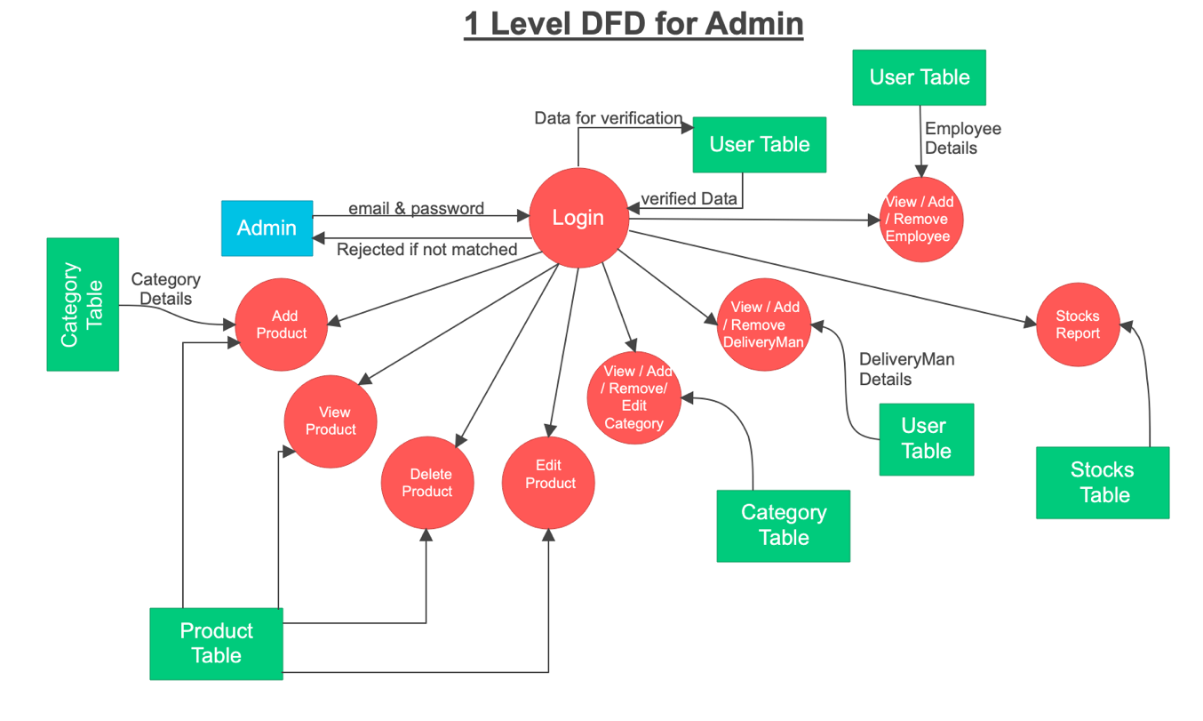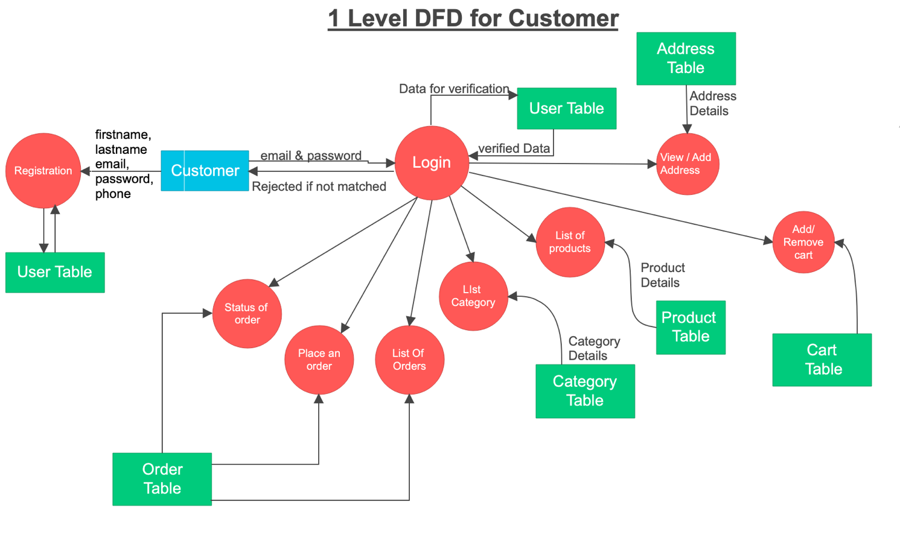

**ER-DIAGRAM SOFTWARE GENERATED:**

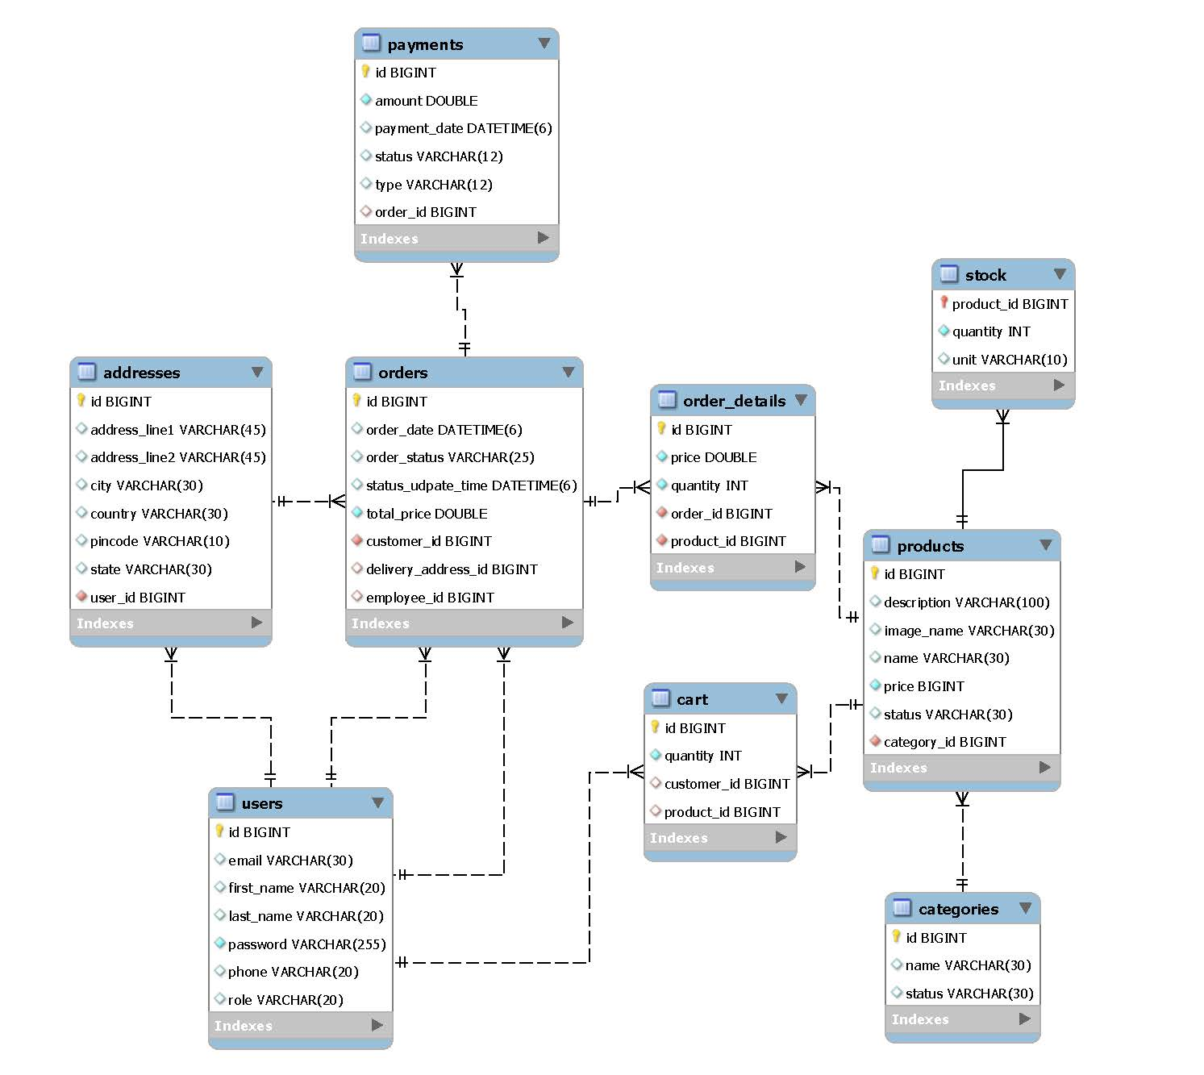

**ER-DIAGRAM MANUAL DRAWING:**

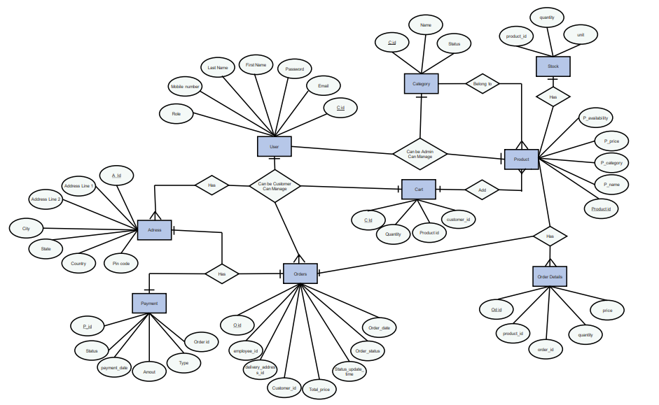

**CLASS DIAGRAM:**

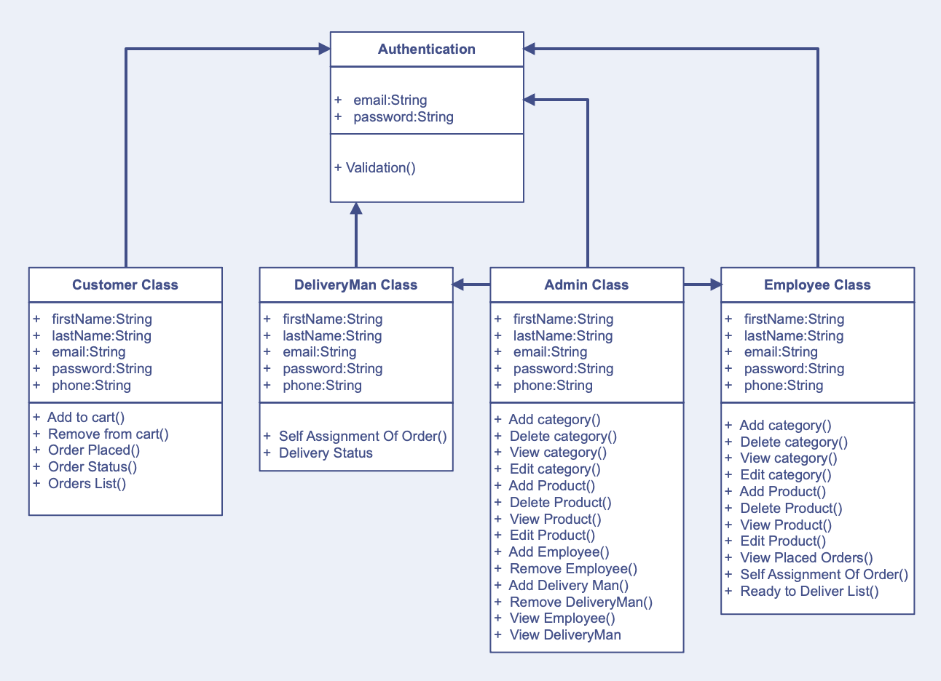

**TABLE STRUCTURE**

**All TABLES:**

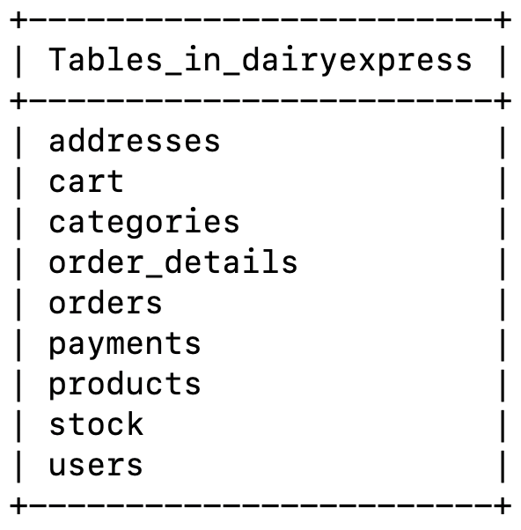

**USERS :**

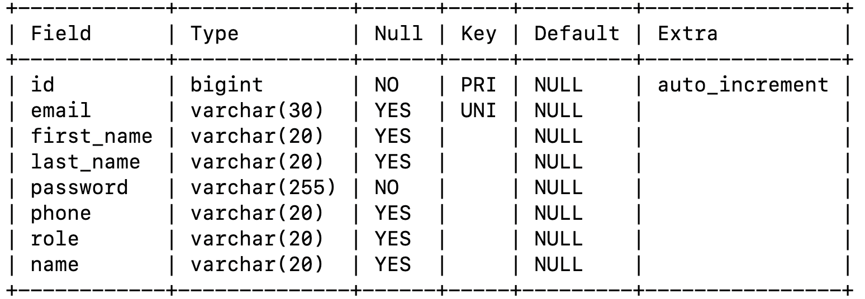

**STOCKS :**

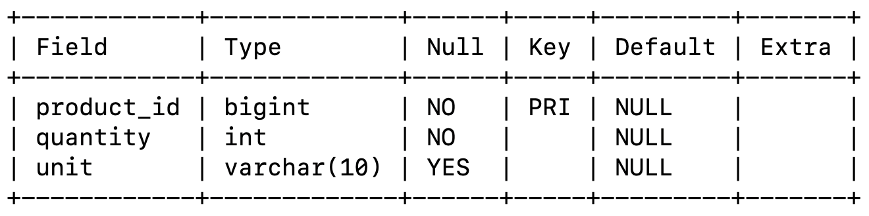

**PRODUCTS :**

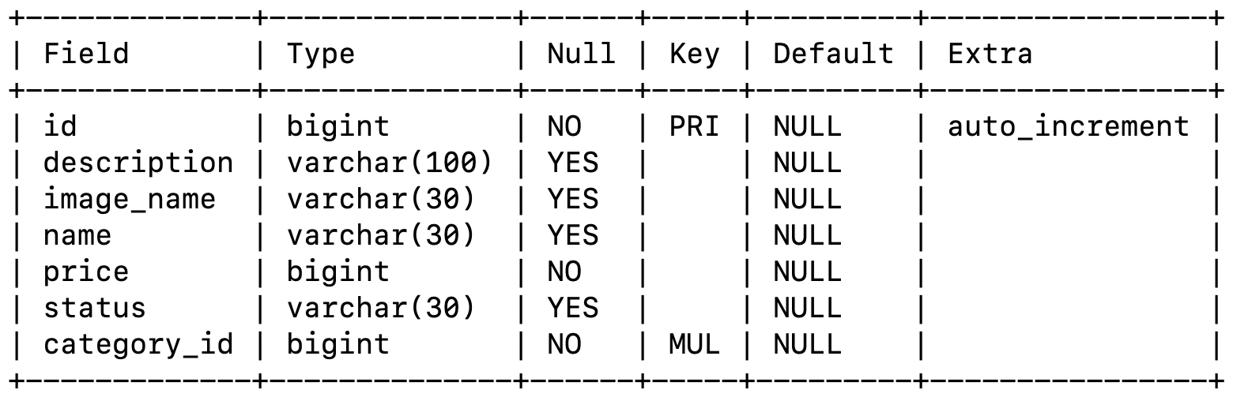

**PAYMENTS:**

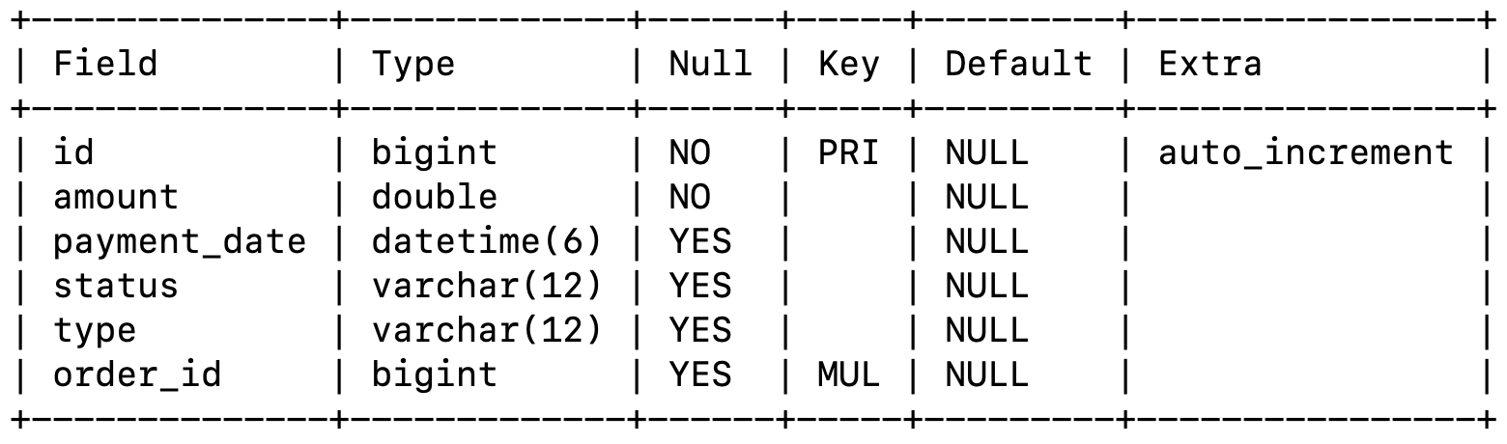

**ORDERS:** 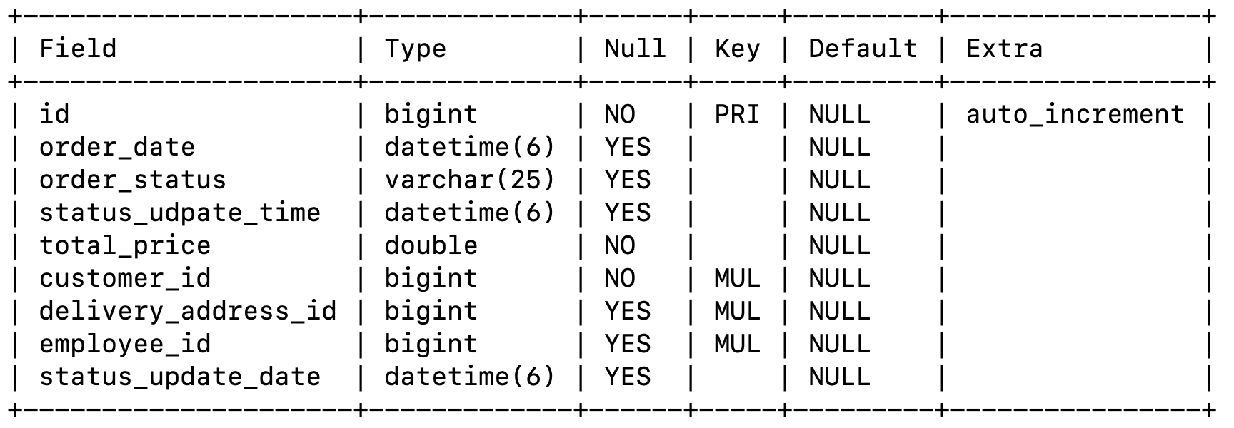

**ORDER_DETAILS:** 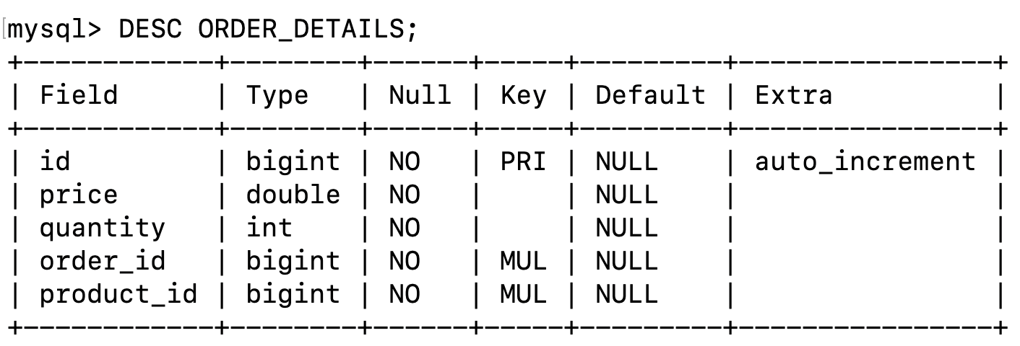

**CART:** 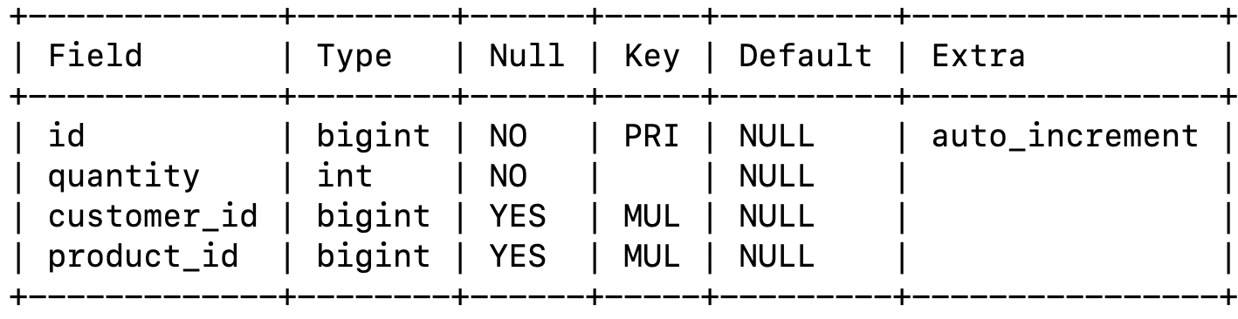

**ADDRESSES:** 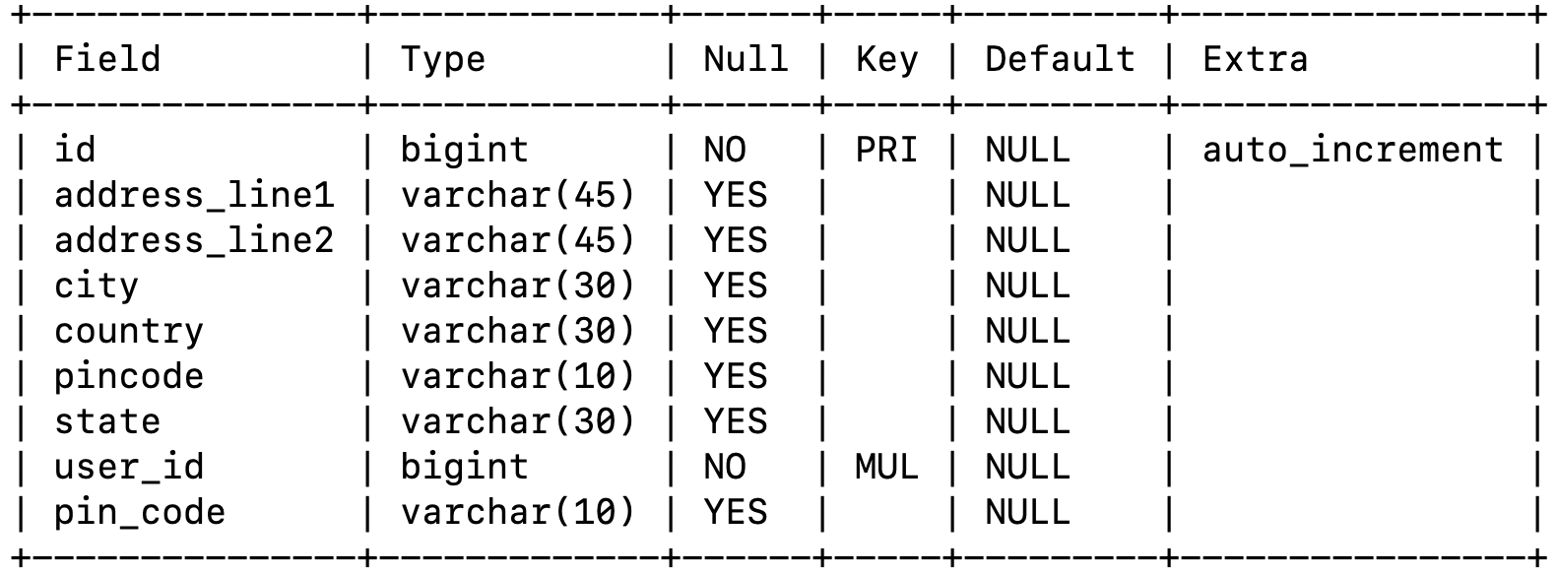

**CATEGORIES:** 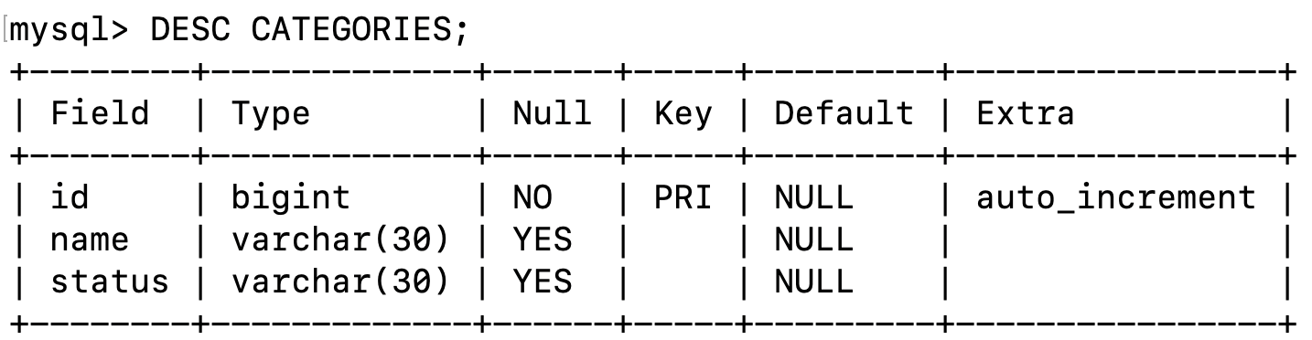

**4.PROJECT SCREENSHOT**

**Home Page:**

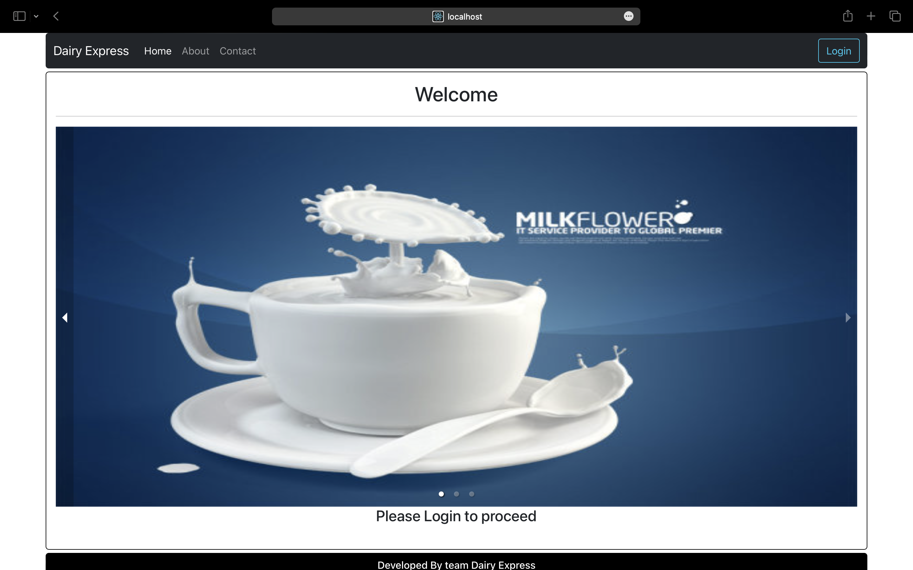

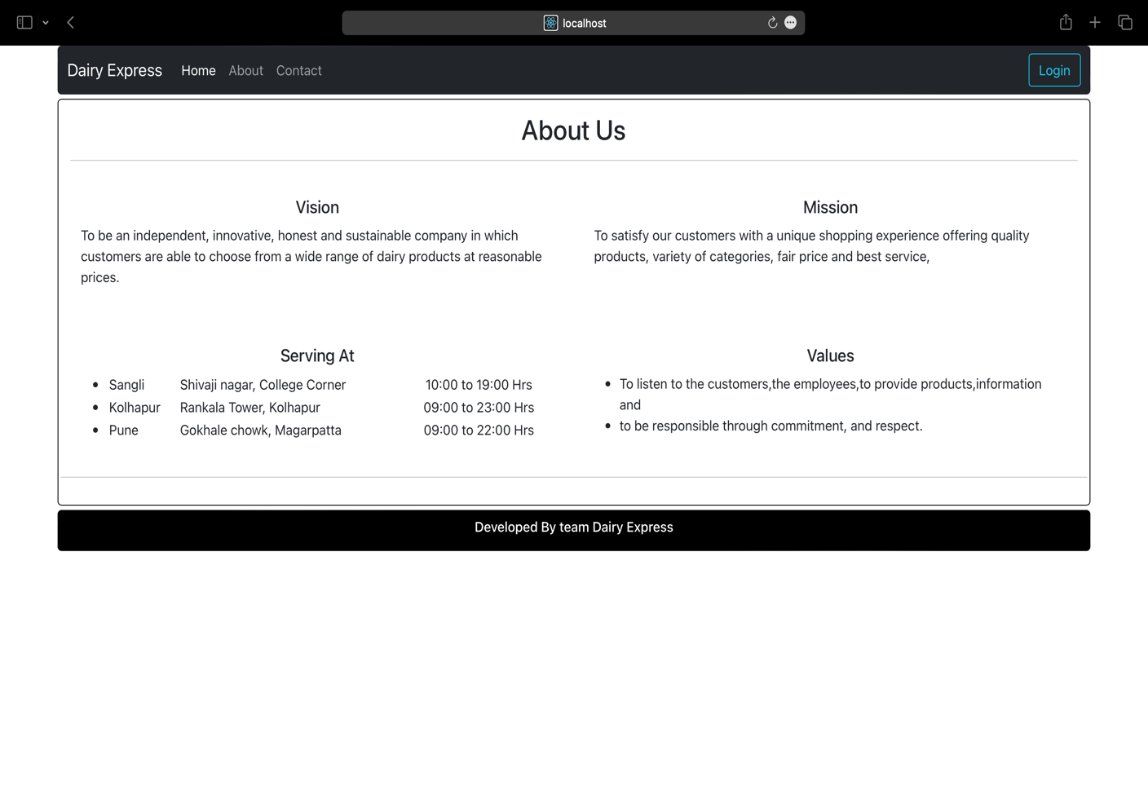**About-Us:**

**Contact:** 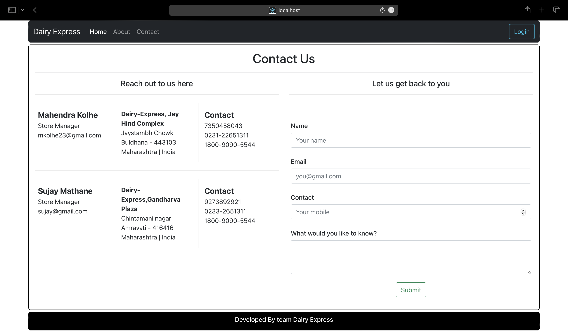

**Login:** 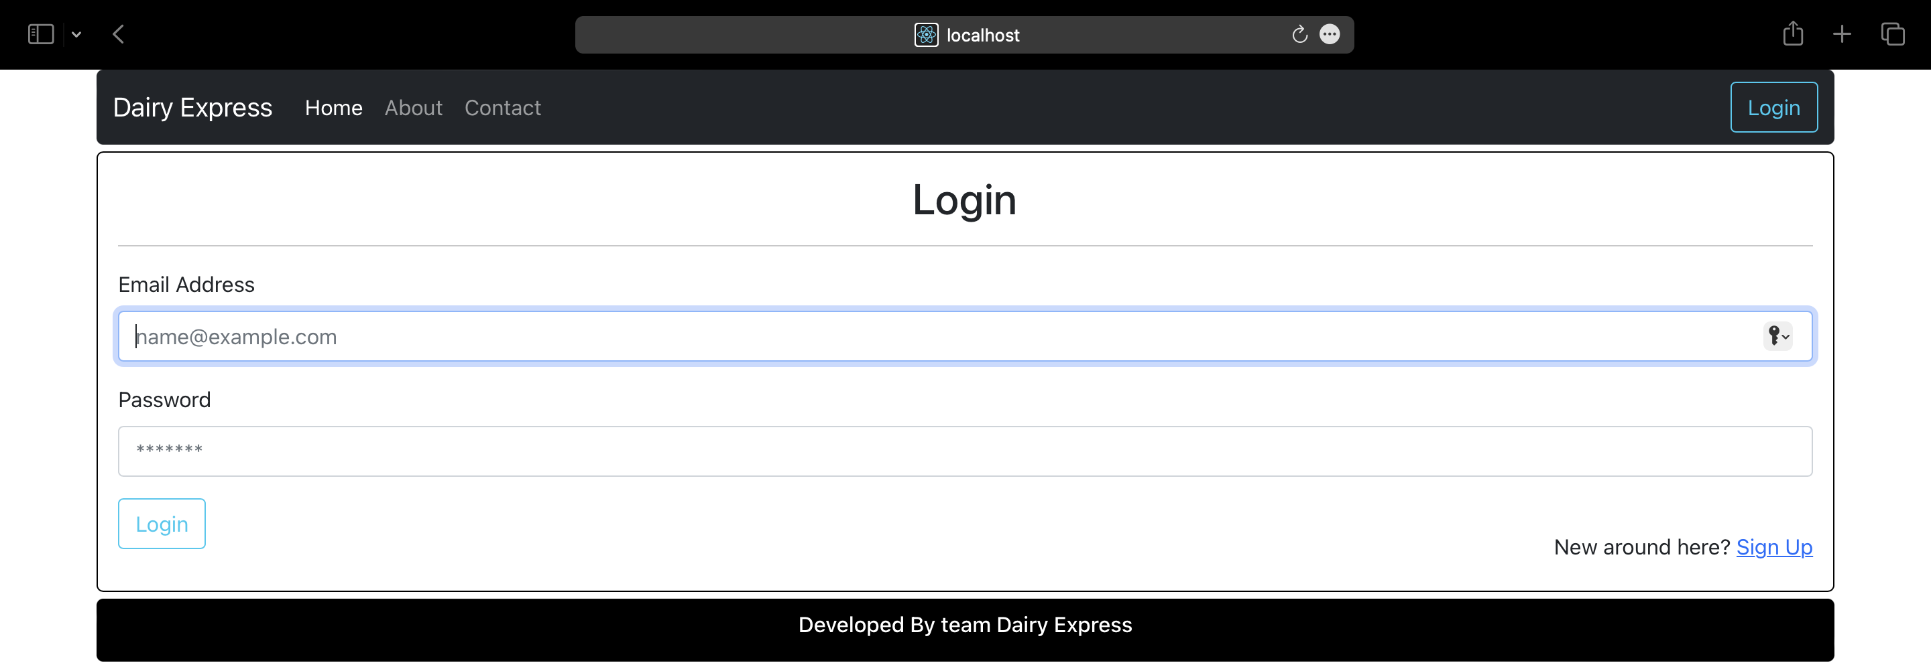

**Admin Welcome Page:** 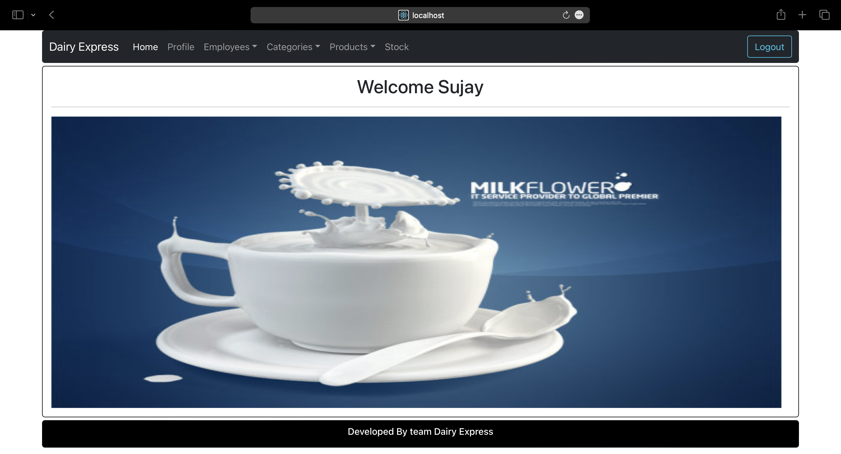

**Admin Editable Profile Page:**

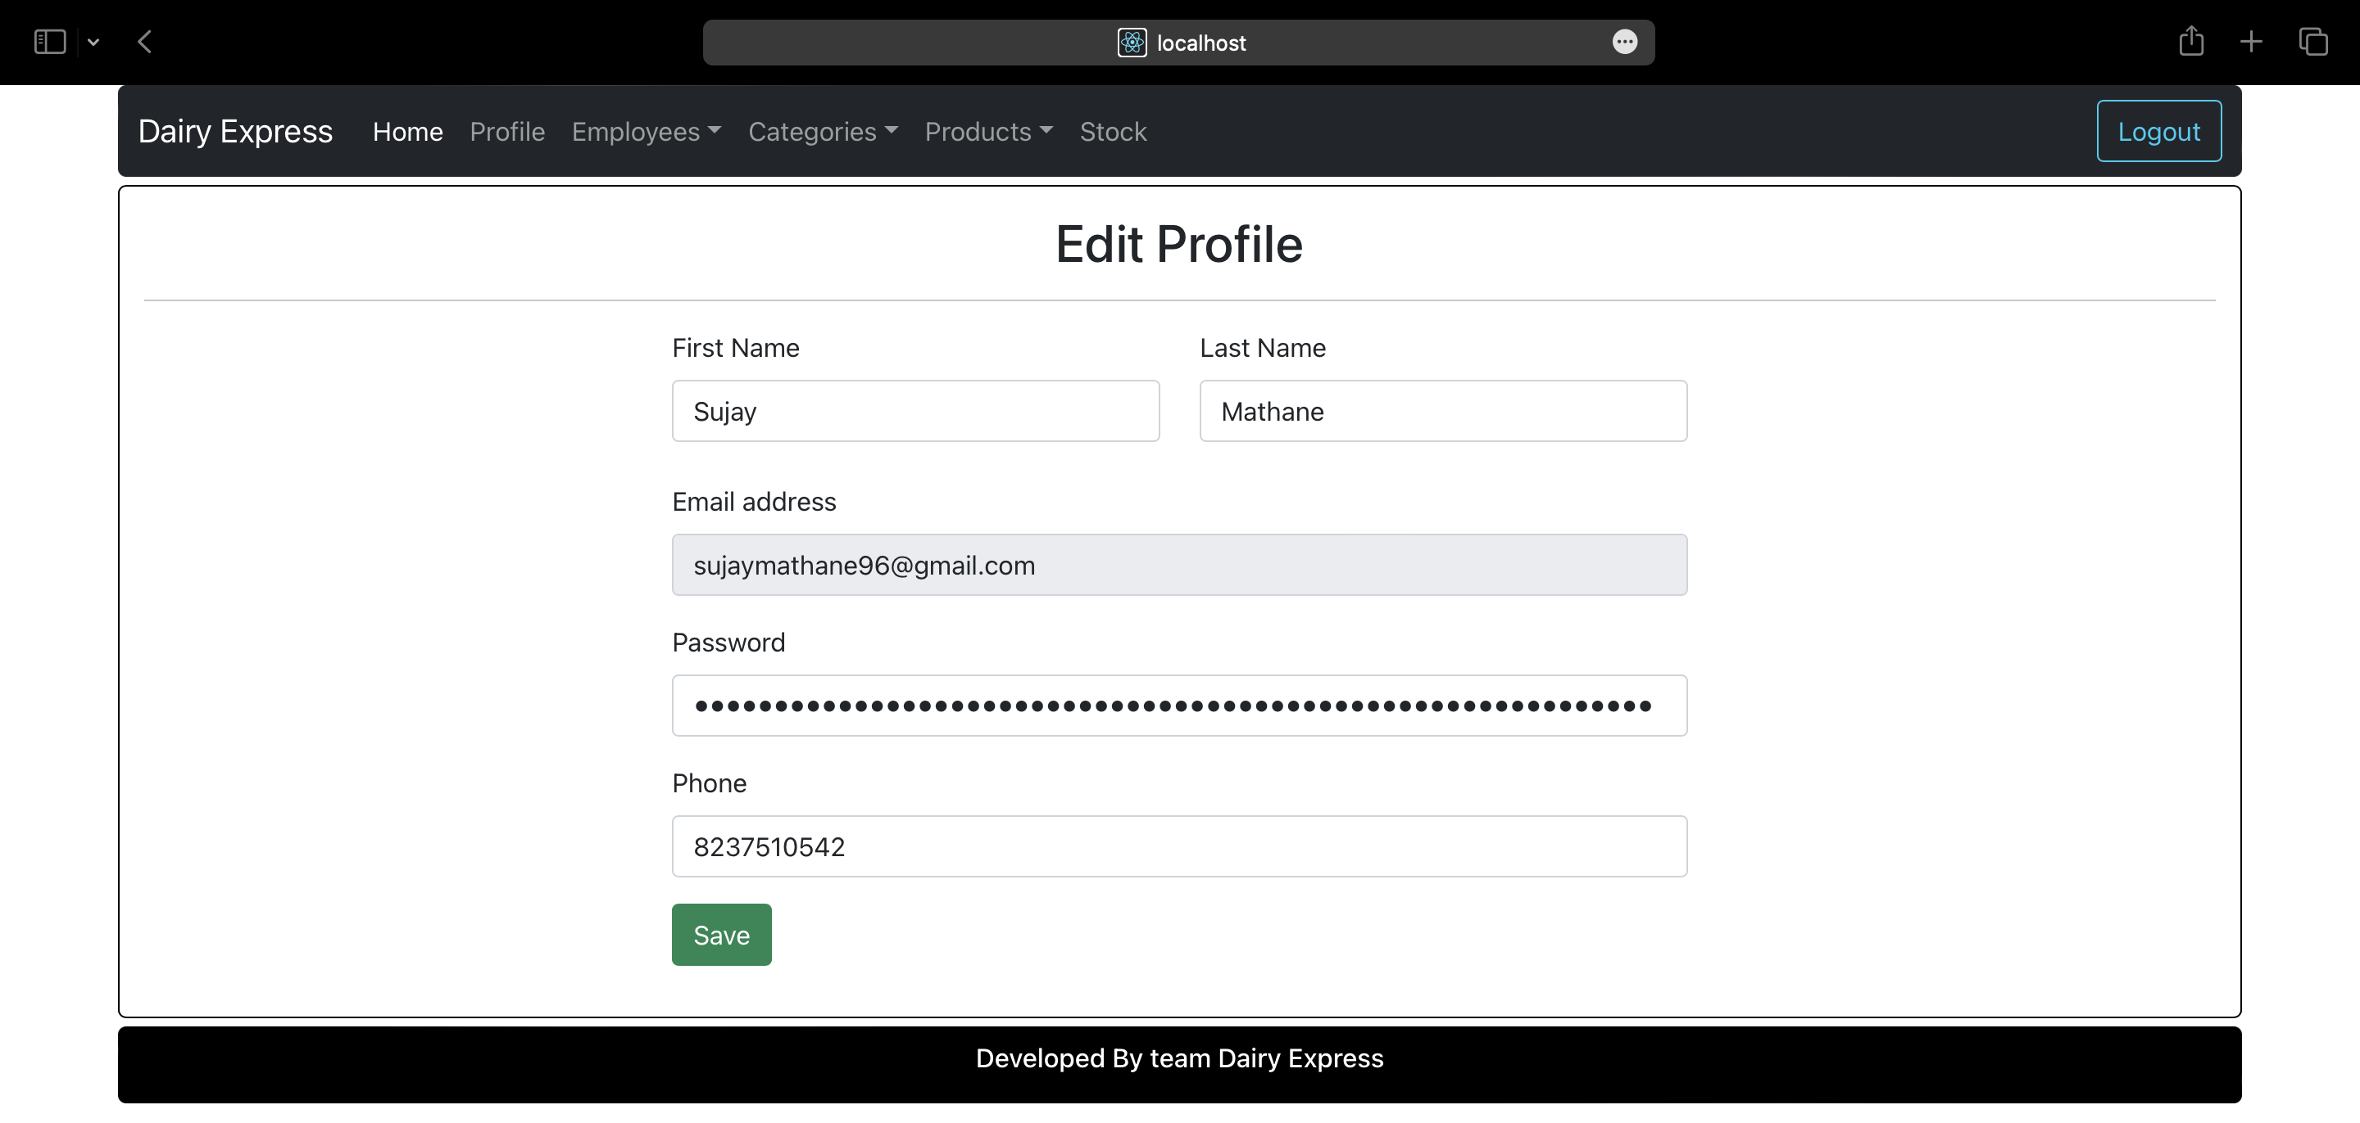

**Admin can Add Product:**

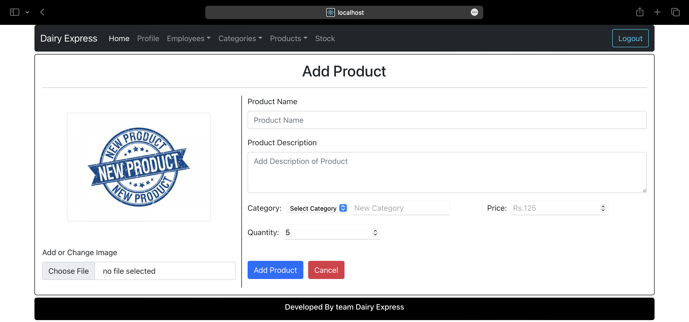

**Admin can View Stock Report:** 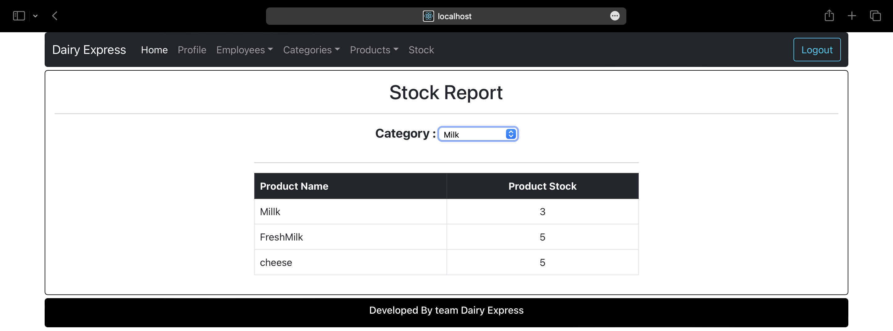

**Admin can Add/Remove Category:** 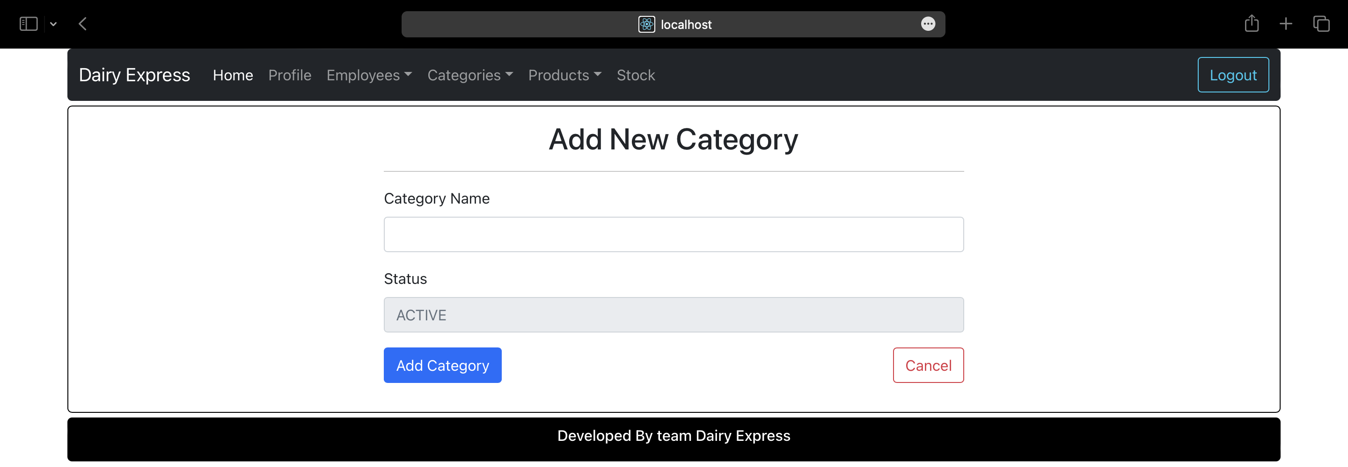

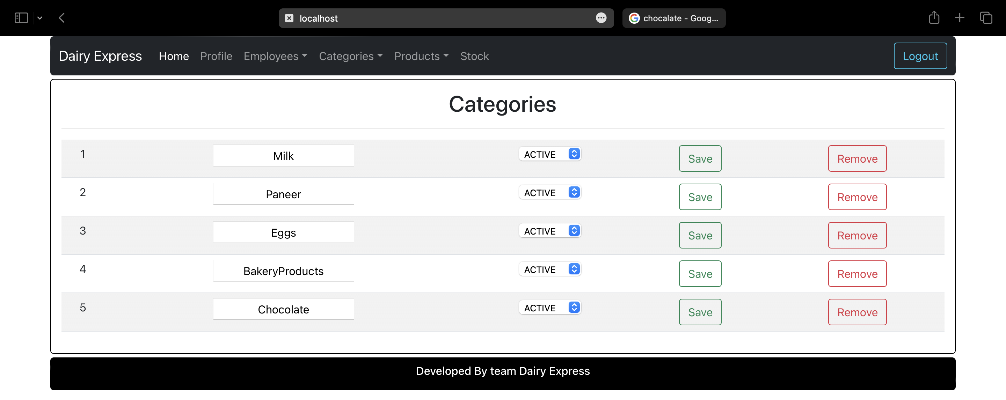

**Admin can Add/View Employee/Delivery Persons:** 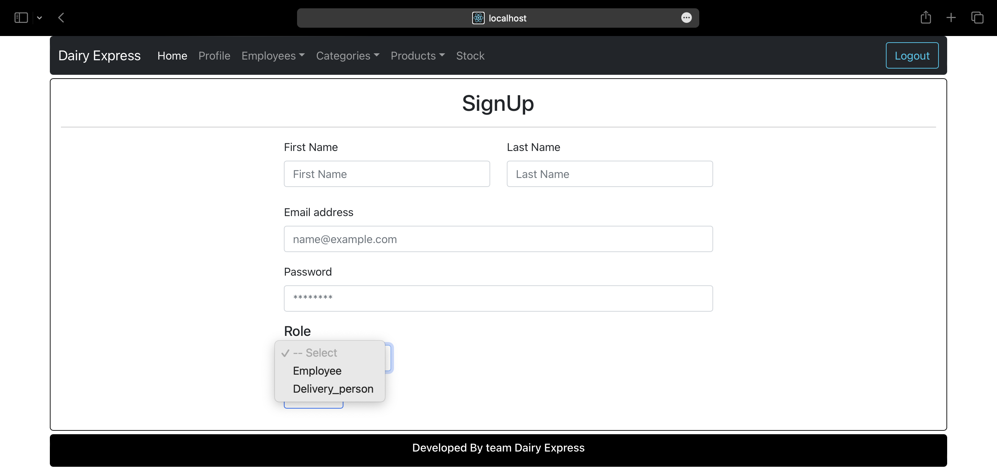

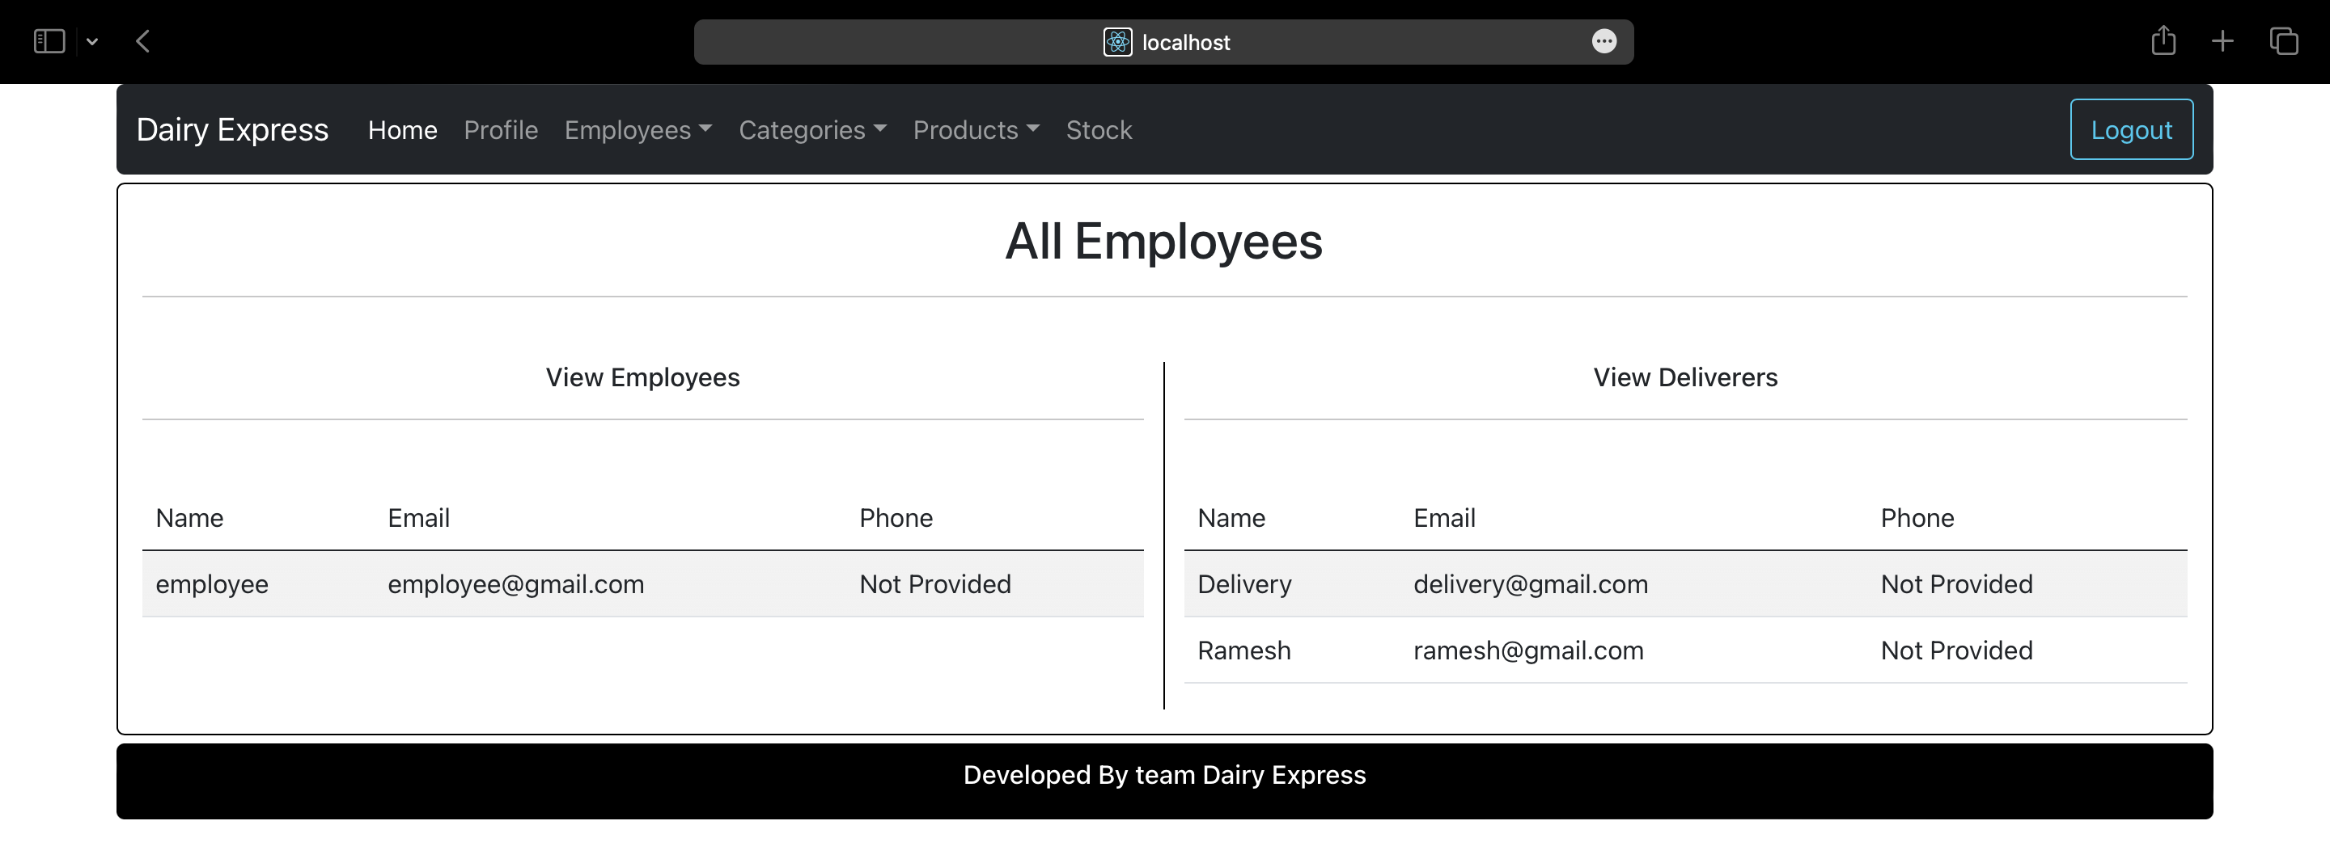

**Customer Login Page With List of Categories :** 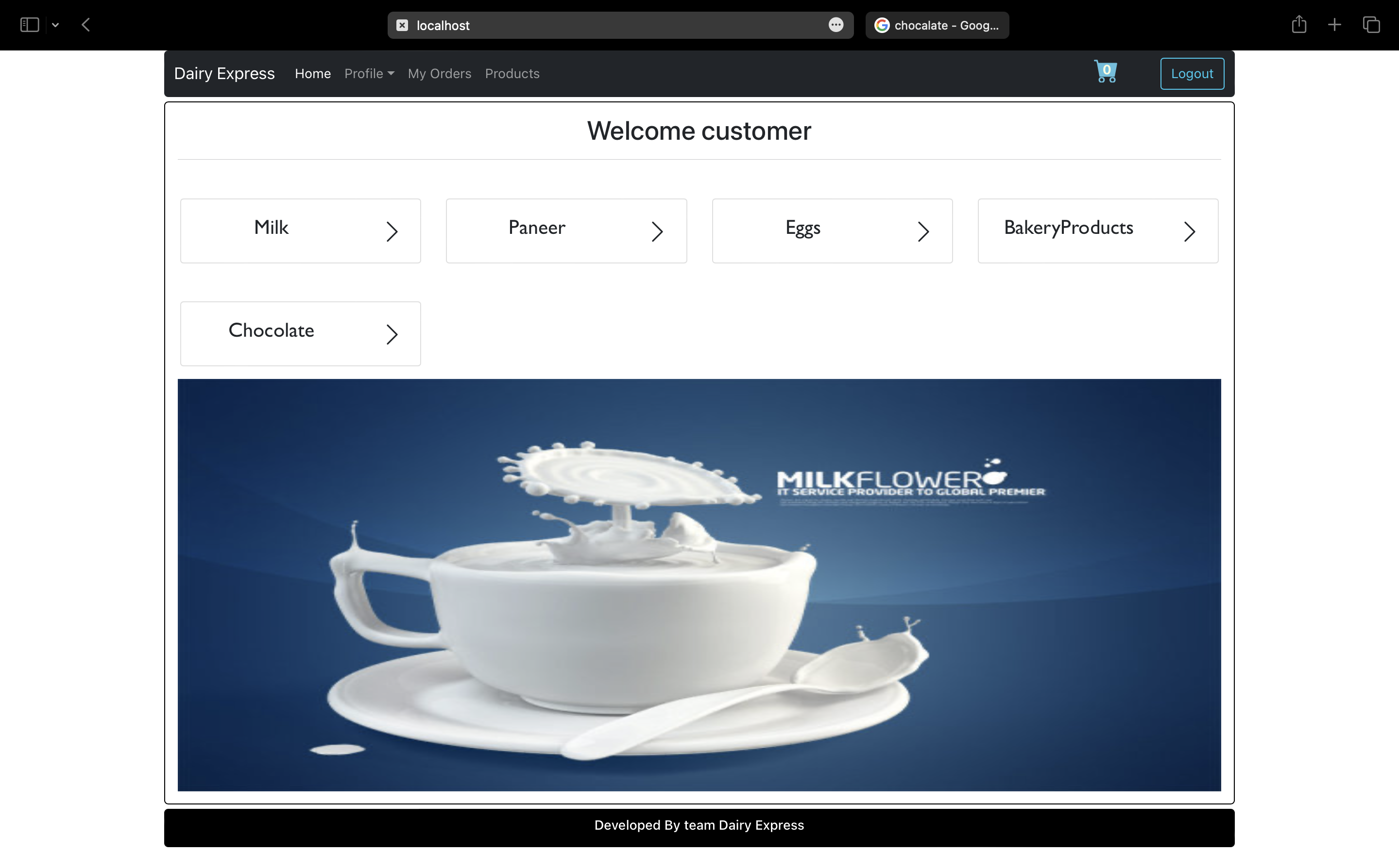

**Customer can view List of Products :** 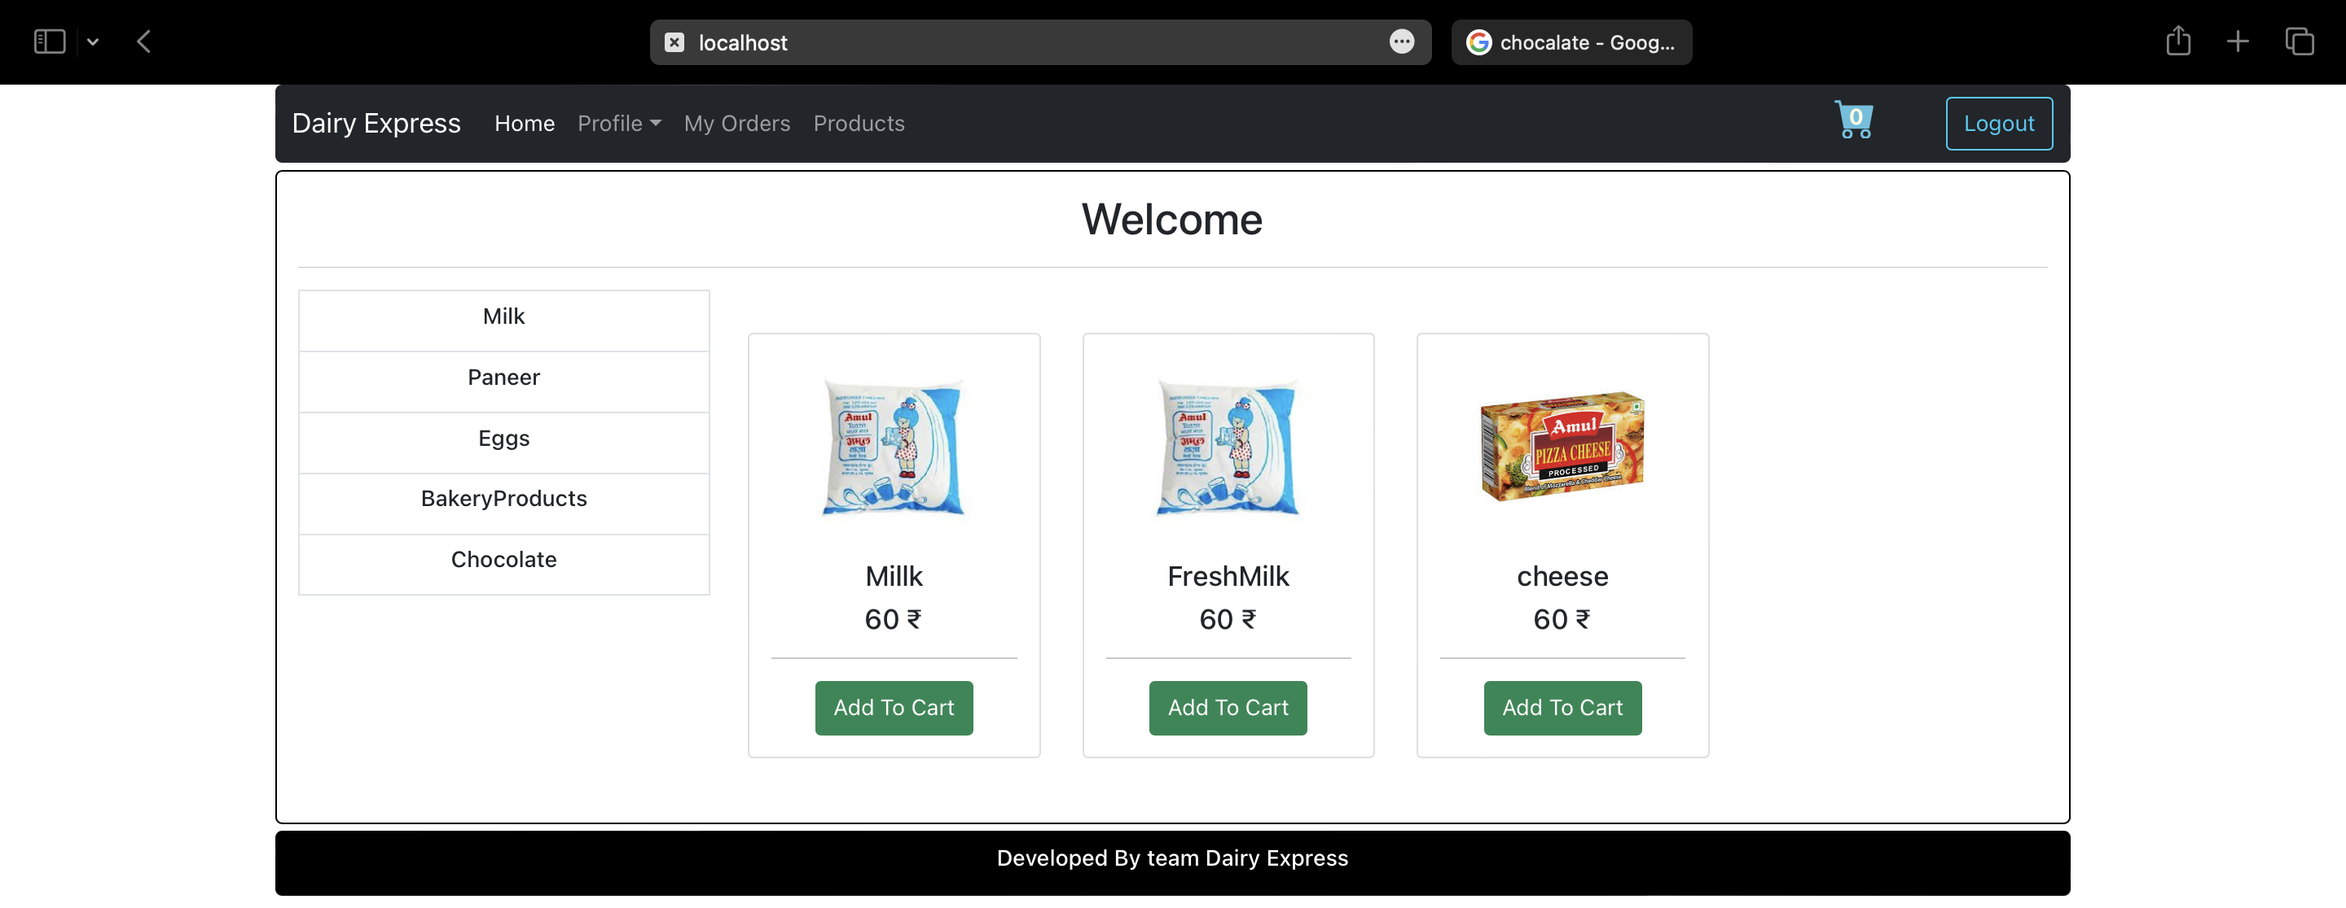

**Customer can Add their address:** 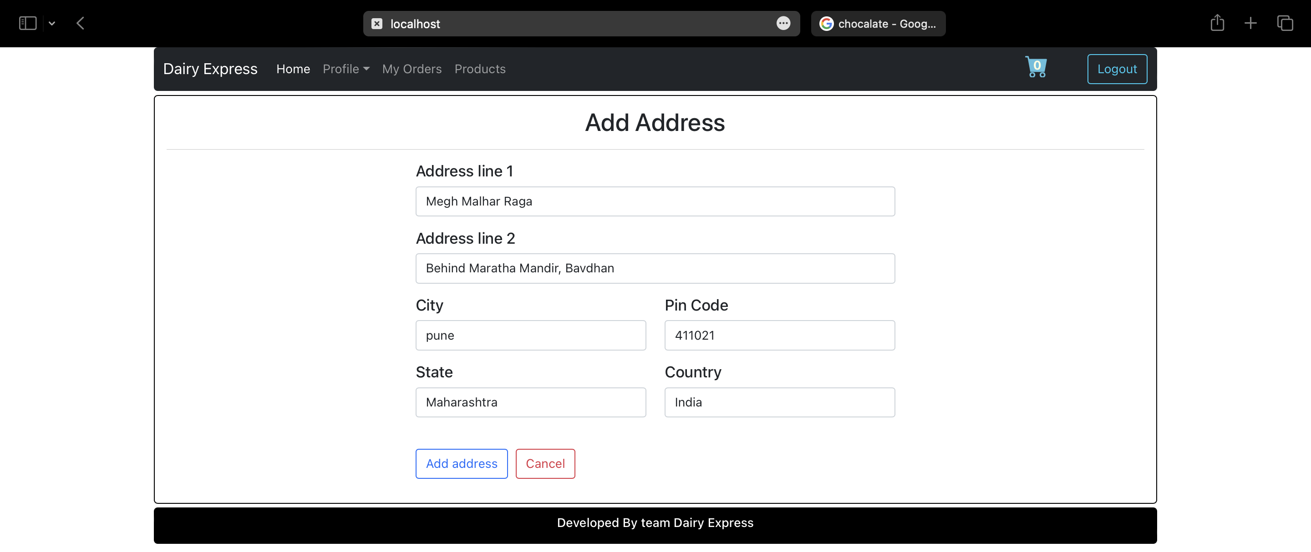

**Review-Order:** 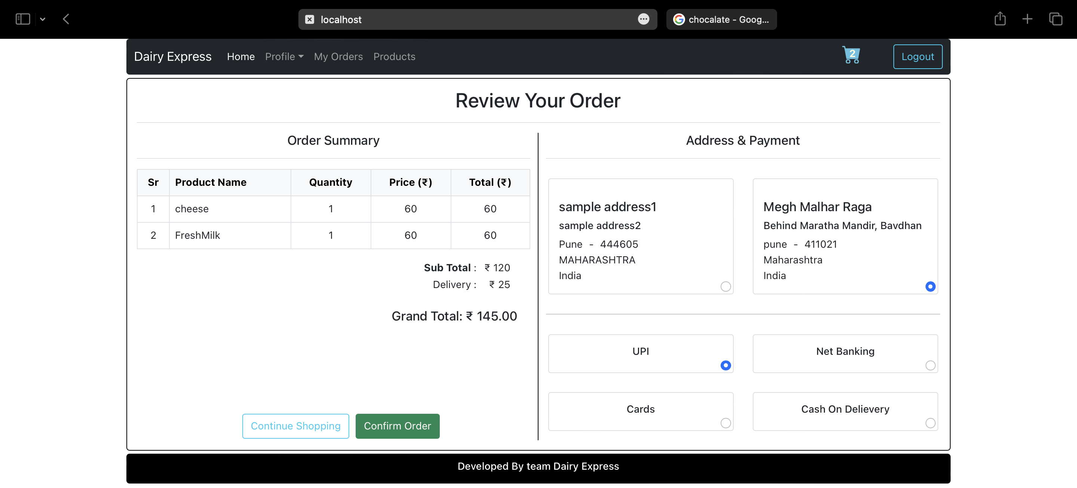

**Customer Order-History:**

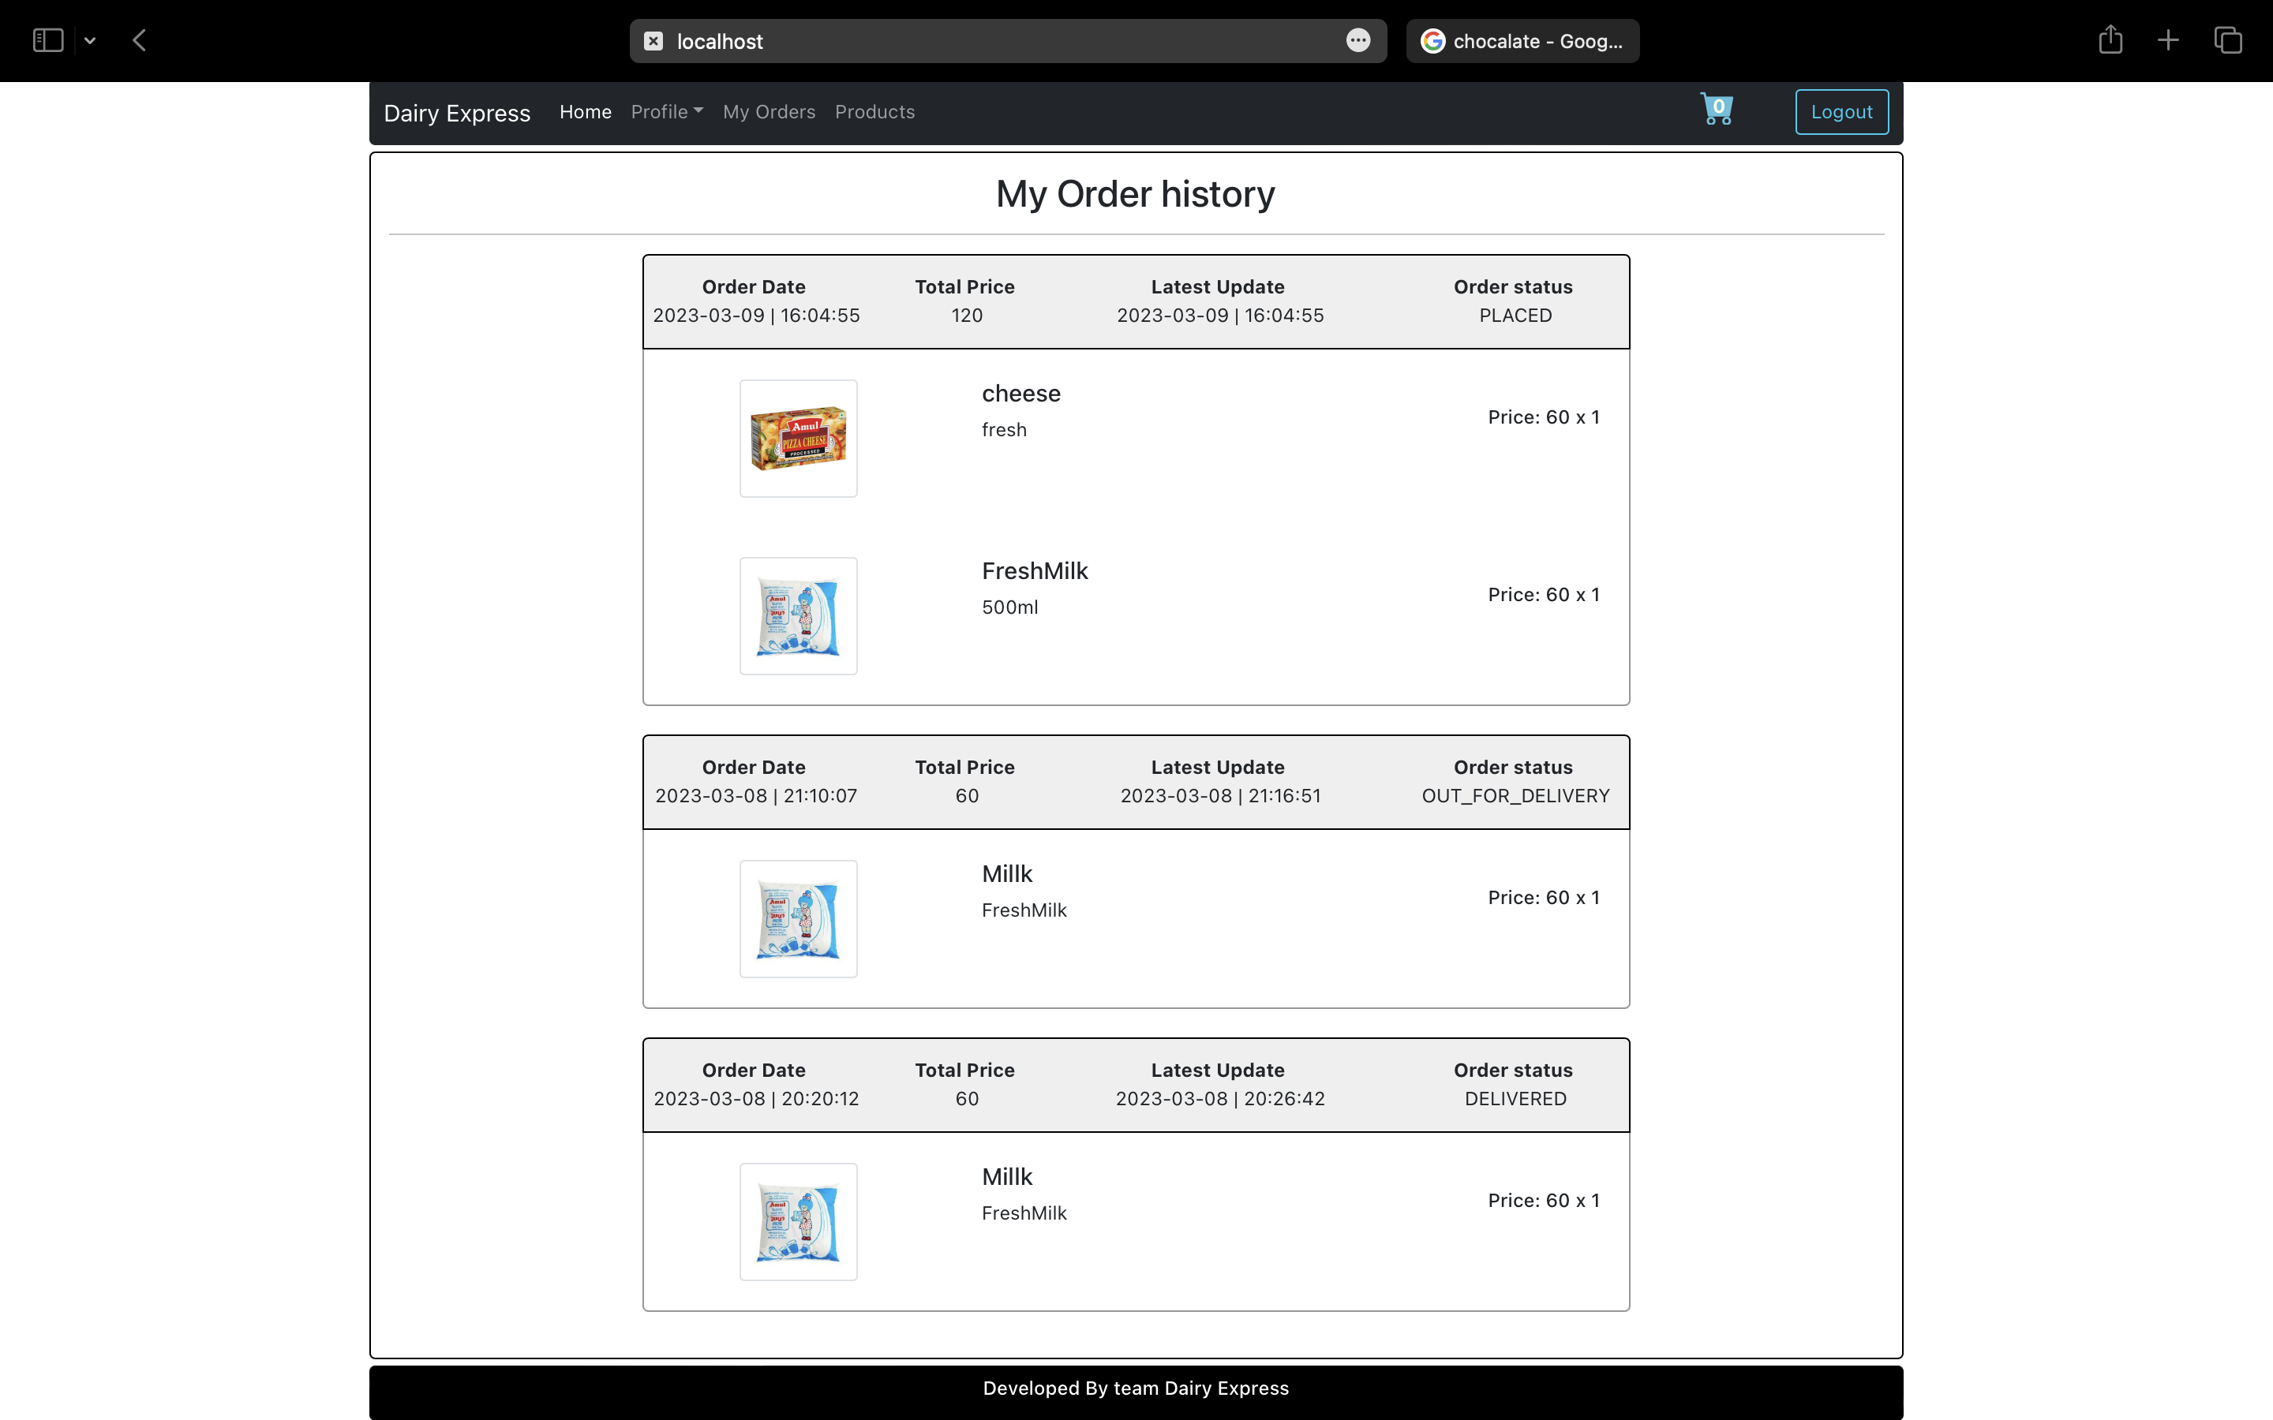

**Delivery-Person Order Management:**

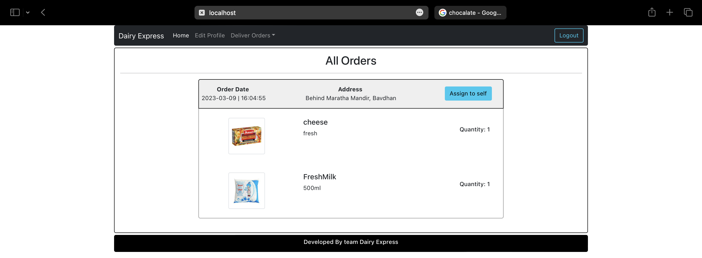

**5.CONCLUSION**

The project entitled **DairyExpress** was completed successfully.

By making online milk product selling we have solved the problem  
from Dairy Express and customer end and more convenience is added to their life.

The system has been developed with much care and free of errors and at the same time it is efficient and less time consuming. The purpose of this project was to develop a web application for purchasing items online.

This project helped us in gaining valuable information and practical knowledge on several topics like designing web pages using React.js, usage of responsive templates and management of database using MySQL. The entire system is secured. Also, the project helped us understanding about the development phases of a project and software development life cycle. We learned how to test different features of a project.

In future scope this system will be available with large scale database and can accommodate many customers. This system can also be developed on mobile application so that it can be access remotely.

Another feature we wished to implement was providing classes for customers so that different offers can be given to each class.

System may keep track of history of purchases of each customer and provide suggestions based on their history. These features could have implemented unless the time did not limit us.

**6.REFERENCES**

### ONLINE REFERENCE:

* 1. [www.reactjs.org](http://www.reactjs.org)
  2. <https://docs.spring.io/spring-boot/docs/current/reference/htmlsingle/>
  3. https://docs.oracle.com/cd/E17952_01/mysql-8.0-en/index.html
  4. https://dev.mysql.com/doc/
  5. [www.w3school.com](http://www.w3school.com/)
  6. [www.javatpoint.com](http://www.javatpoint.com/)